Practical File

of

**Internet of Things Lab**

**(Paper code :-ETCT-352)**



MAHARAJA AGRASEN INSTITUTE OF TECHNOLOGY

SECTOR-22 , ROHINI , NEW DELHI

SUBMITTED TO : SUBMITTED BY:-

**Dr Tripti Lamba**

(Associate Professor-AI &ML Dept.) SHUBHANSHU KAKKAR

ENROLL.NO:**04814812720**

GROUP :- **6CST3**

BRANCH:- CST

SEMESTER : **6th**

**INDEX**

|  |  |  |  |  |  |  |  |  |  |  |
| --- | --- | --- | --- | --- | --- | --- | --- | --- | --- | --- |
| **Exp. No.** | **Experiment Name** | **Date of Performing** | **R1 (3)** | **R2**  **(3)** | **R3**  **(3)** | **R4**  **(3)** | **R5**  **(3)** | **Total Marks (15)** | **Remarks** | **Sign.** |
| 1 |  |  |  |  |  |  |  |  |  |  |
| 2 |  |  |  |  |  |  |  |  |  |  |
| 3 |  |  |  |  |  |  |  |  |  |  |
| 4 |  |  |  |  |  |  |  |  |  |  |
| 5 |  |  |  |  |  |  |  |  |  |  |
| 6 |  |  |  |  |  |  |  |  |  |  |
| 7 |  |  |  |  |  |  |  |  |  |  |
| 8 |  |  |  |  |  |  |  |  |  |  |
| 9 |  |  |  |  |  |  |  |  |  |  |
| 10 |  |  |  |  |  |  |  |  |  |  |

# **EXPERIMENT-1**

**AIM-** Familiarization with Arduino/Raspberry Pi and perform necessary software installation.

**OBJECTIVES:**

1. To Study hardware and software related to IoT.
2. To understand the function of Node MCU, Arduino Uno and Raspberry Pi.

**ARDUINO**

Arduino is an open-source hardware and software platform designed for building and prototyping electronics projects. The platform is based on a microcontroller board that can be programmed to control various components and interact with sensors, motors, and other electronic devices.

Arduino boards come in different sizes and shapes, but they all have some common features such as digital and analog input/output pins, USB interface, and a power jack. They also have a built-in bootloader, which allows them to be programmed using a simple USB cable and the Arduino Integrated Development Environment (IDE).

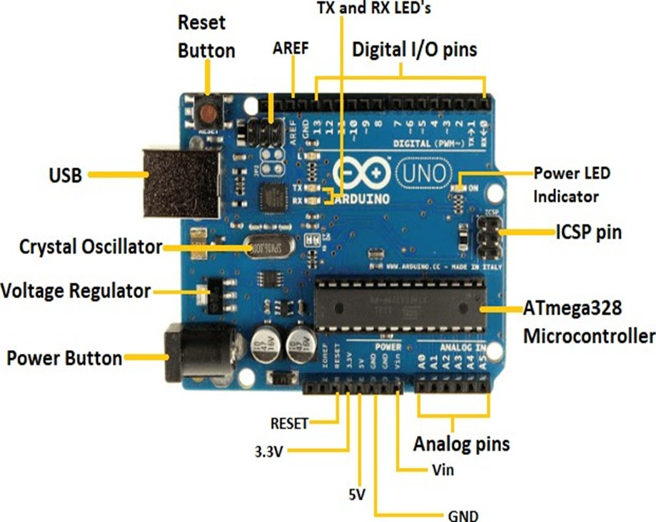

**Components of Arduino :-**

1. Microcontroller: This is the heart of the Arduino board, and it is usually an Atmel AVR microcontroller. The microcontroller processes the input data and executes the code written in the Arduino IDE. The processor code inside it is of 8-bit. It combines Memory (SRAM, EEPROM, and Flash), Analog to Digital Converter, SPI serial ports, I/O lines, registers, timer, external and internal interrupts, and oscillator.
2. Clock crystal: This is a small crystal oscillator that provides the clock signal to the microcontroller. The clock signal is used to synchronize the execution of instructions in the microcontroller. The Crystal oscillator has a frequency of 16MHz, which makes the Arduino UNO a powerful board.
3. Voltage regulator: The voltage regulator is used to regulate the input voltage to a stable voltage level that can be used by the microcontroller and other components on the board. The voltage regulator converts the input voltage to 5V.
4. Power supply connector: This connector is used to connect an external power source to the board. The voltage level of the external power source should be within the acceptable range specified by the board.
5. USB connector: This connector is used to connect the Arduino board to a computer for programming and communication.
6. TX – RX LEDs: TX stands for transmit, and RX for receive. These are indicator LEDs which blink whenever the UNO board is transmitting or receiving data.
7. Reset button: This button is used to reset the microcontroller and restart the execution of the program.
8. Digital I/O pins- The digital pins have the value HIGH or LOW. The pins numbered from D0 to D13 are digital pins.
9. Analog Pins- The pins numbered from A0 to A5 are analog pins. The function of Analog pins is to read the analog sensor used in the connection. It can also act as GPIO (General Purpose Input Output) pins.
10. GND- Ground pins. The ground pin acts as a pin with zero voltage.

**Pin configuration in Arduino**

The Arduino Uno has a total of 31 pins (1 NC) among which 14 pins are digital pins that can be used for digital inputs and output. 6 of them are the analog pins that can be used for analog inputs and outputs and there are 10 pins that can be used to supply power to the connected devices.

There are three main types of Arduino pins: digital pins, analog pins

and power pins.:-

* Digital pins can be used as both input and output pins on most Arduino

microcontrollers. This means that a single pin can both send and receive

digital data. Digital Arduino pins can be only "high" or "low." When a

digital pin is high, a constant voltage is present. When the pin is low, this

voltage is gone.

Switching a light emitting diode (LED) on and off is one common instance

of a digital output, and checking the status of a button is an example of a

digital input.

* Analog input pins are used to read the state of a connected device,

such as a sensor. Although digital pins can only tell if a connection is high

or low, analog input pins are able to read the exact voltage value. This is

useful for interfacing with analog sensors that have a wide range of

possible values. For example, analog thermometer sensors often send a

voltage reading that corresponds to the temperature. Using an analog

input pin, an Arduino can read the value directly.

* The Vin, 5V, 3.3V, and GND pins are Arduino power pins. You can use the Vin pin to Power your Arduino with an unregulated 7 to 12-volt power source. Like a 9V battery or a wall adapter that is in the range of 7 to 12 volts. Alternatively, you can power your Arduino through the 5V pin with an external regulated 5V power supply.

Additionally, the Arduino Uno board has a few other pins that serve special purposes:

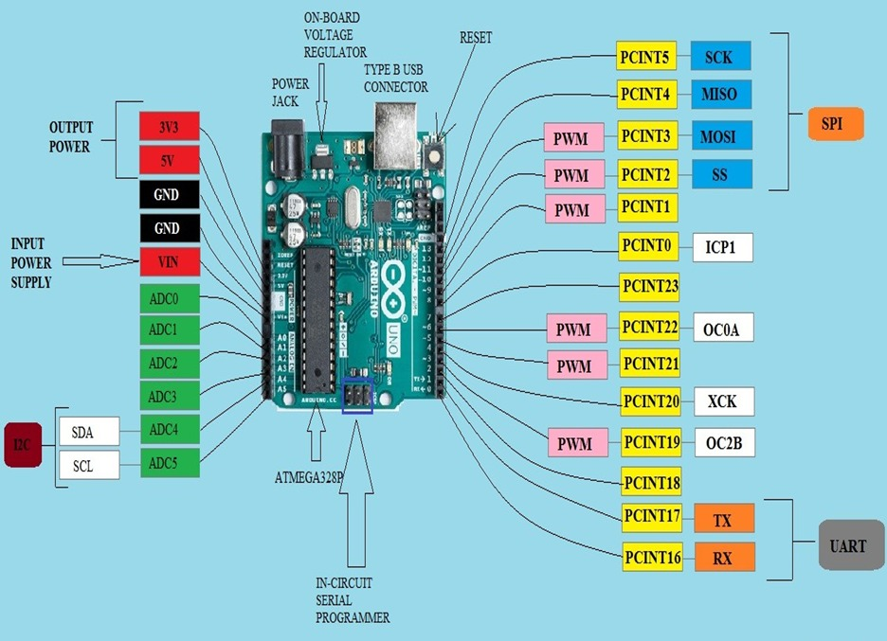

* Reset Pin: The reset pin is used to restart the microcontroller and restart the execution of the program.
* Serial Pins: The Arduino Uno board has two serial communication pins, RX and TX, which can be used for serial communication with other devices.
* PWM Pins: Some of the digital I/O pins on the Arduino Uno board can also be used as Pulse Width Modulation (PWM) pins, which can be used to generate analog signals with varying pulse widths
* SPI Pins: This is the Serial Peripheral Interface pin, it is used to maintain SPI communication with the help of the SPI library. SPI pins include:

SS: Pin number 10 is used as a Slave Select

MOSI: Pin number 11 is used as a Master Out Slave In

MISO: Pin number 12 is used as a Master In Slave Out

SCK: Pin number 13 is used as a Serial Clock.

**Program an Arduino:**

The most important advantage with Arduino is the programs can be directly loaded to the device without requiring any hardware programmer to burn the program

This is done because of the presence of the 0.5KB of Boot-loader, which allows the program to be burned into the circuit.

All we have to do is to download the Arduino software and writing the code.

The Arduino tool window consists of the toolbar with the buttons like verify, upload, new, open, save, serial monitor.

It also consists of a text editor to write the code, a message area which displays the feedback like showing the errors, the text console which displays the output and a series of menus like the File, Edit, Tools menu.

**Steps to program an Arduino:-**

1. Programs written in Arduino are known as sketches. A basic sketch consists of 3 parts

a. Declaration of Variables

b. Initialization: It is written in the setup () function.

c. Control code: It is written in the loop () function.

2. The sketch is saved with .ino extension. Any operations like verifying, opening a sketch, saving a sketch can be done using the buttons on the toolbar or using the tool menu.

3. The sketch should be stored in the sketchbook directory.

4. Chose the proper board from the tools menu and the serial port numbers.

5. Click on the upload button or chose upload from the tools menu. Thus the code is uploaded by the boot loader onto the micro controller.

Basic Arduino functions are:

1. **digitalRead(pin):** Reads the digital value at the given pin.

2. **digital.Write(pin, value):** Writes the digital value to the given pin.

3. **pin.Mode(pin, mode):** Sets the pin to input or output mode.

4. **analog.Read(pin):** Reads and returns the value.

5. **analogWrite(pin, value):** Writes the value to that pin.

6. **serial.begin(baud rate):** Sets the beginning of serial communication by setting the bit rate.

**INSTALLING THE ARDUINO IDE:-**

**Steps:-**

Step1: Visit http://www.arduino.cc/en/main/software to download the latest Arduino IDE version for your computer’s operating system. There are versions for Windows, Mac, and Linux systems. At the download page, click on the “Windows Installer” option for the easiest installation.

Step-2: On that page, there are 3 download options for Windows

Windows Installer : The software will be installed in Windows operating system and required admin access.

Windows Zip file : To make a portable installation.

Windows App : for Windows 8.1 or 10.

Step3: Click Windows Installer, then click "just download”

Step4: After the download is complete, open the installer file and start installing.

Step5: After the file is run, the "License Agreement" page will appear. You can read it, then click "I Agree" to continue.

Step-6: Check the component that you want to install and uncheck the components that you don't want to install. I suggest installing all component. Click "next" to continue.

Step-7: Arduino will automatically be installed in "C:\Program Files (x86)\Arduino". If you want to change the folder, click "Browse" and select the desired folder. Click install to start the installation.

Step-8: After the installation process is complete, there will be an Arduino icon on the Desktop. Or check on the search icon and write "arduino". If you have found the arduino icon, run the application.

**Steps with pics :-**

**Step1:**

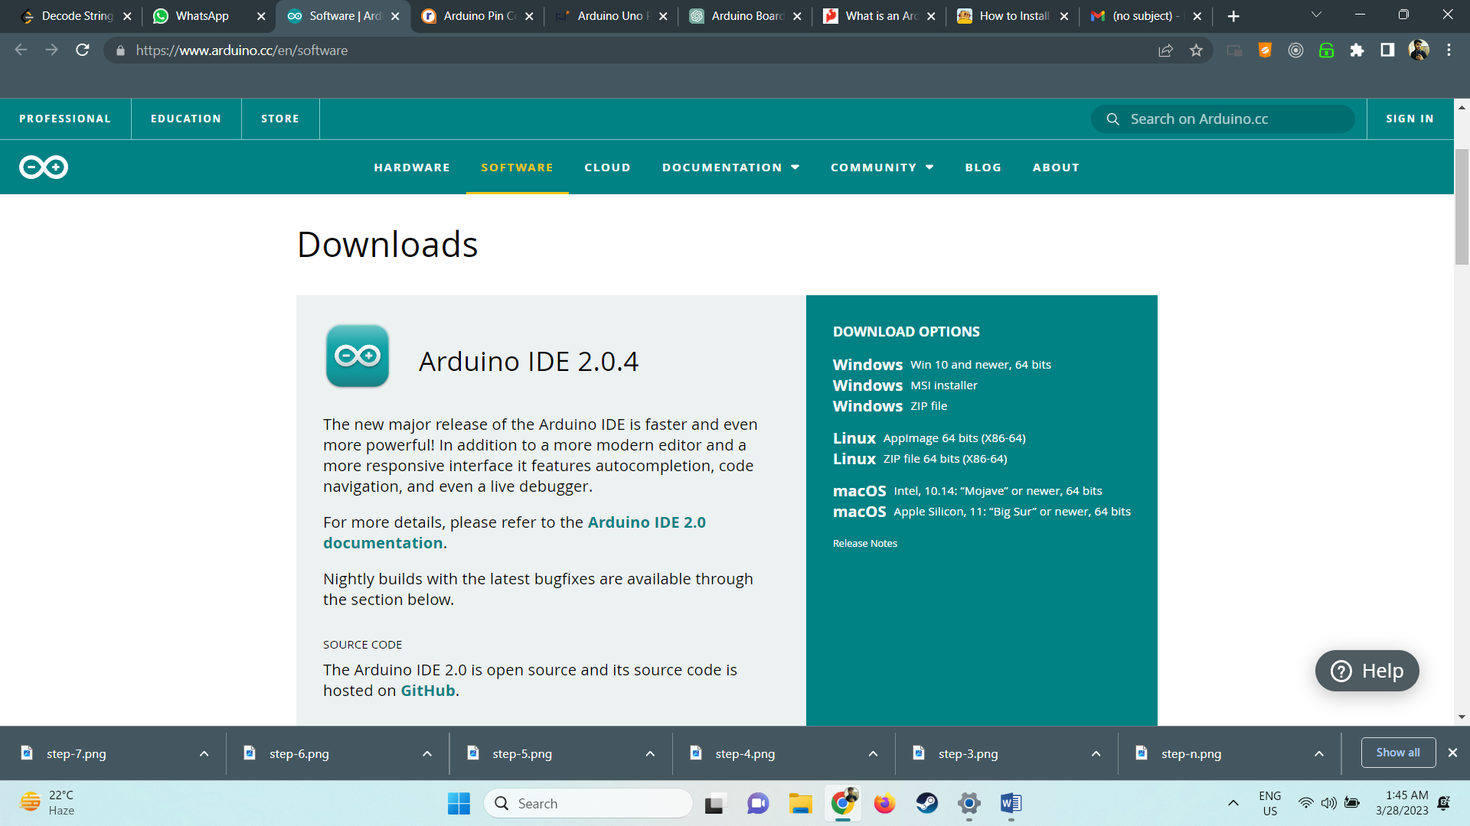

**Step2:**

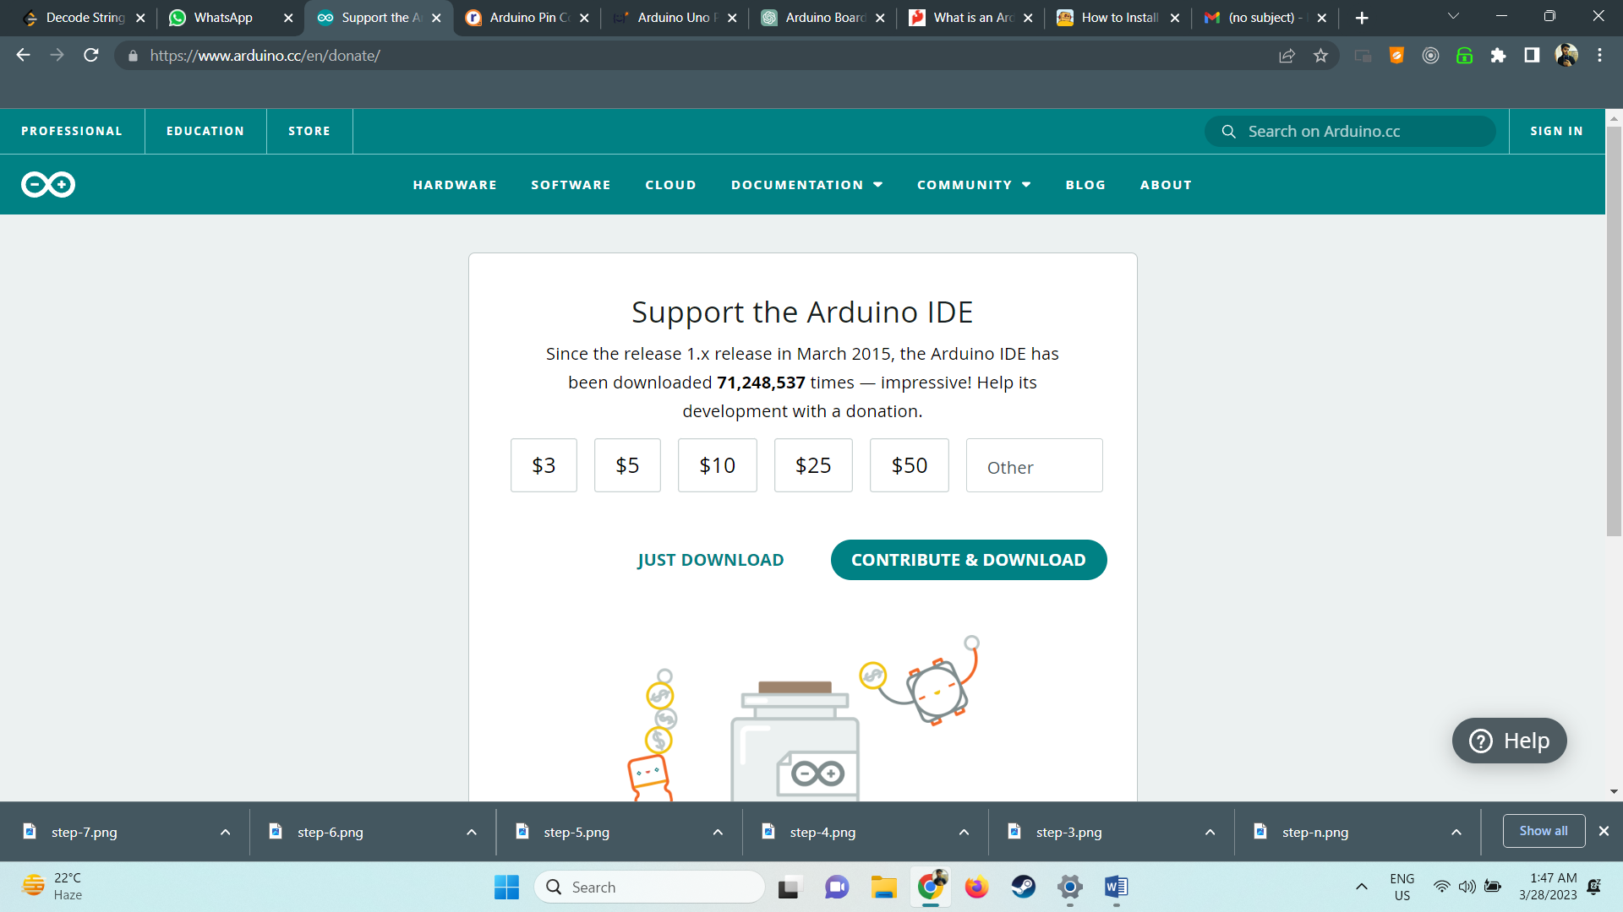

**Step 3:**

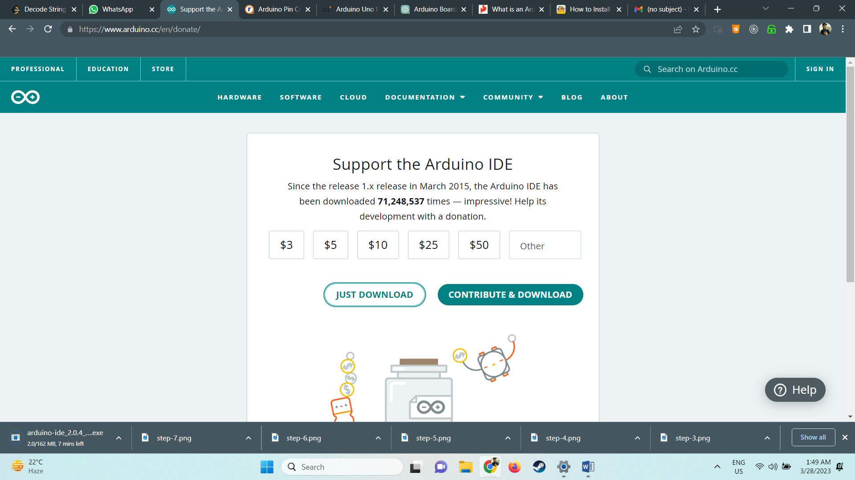

**Step 4:-**

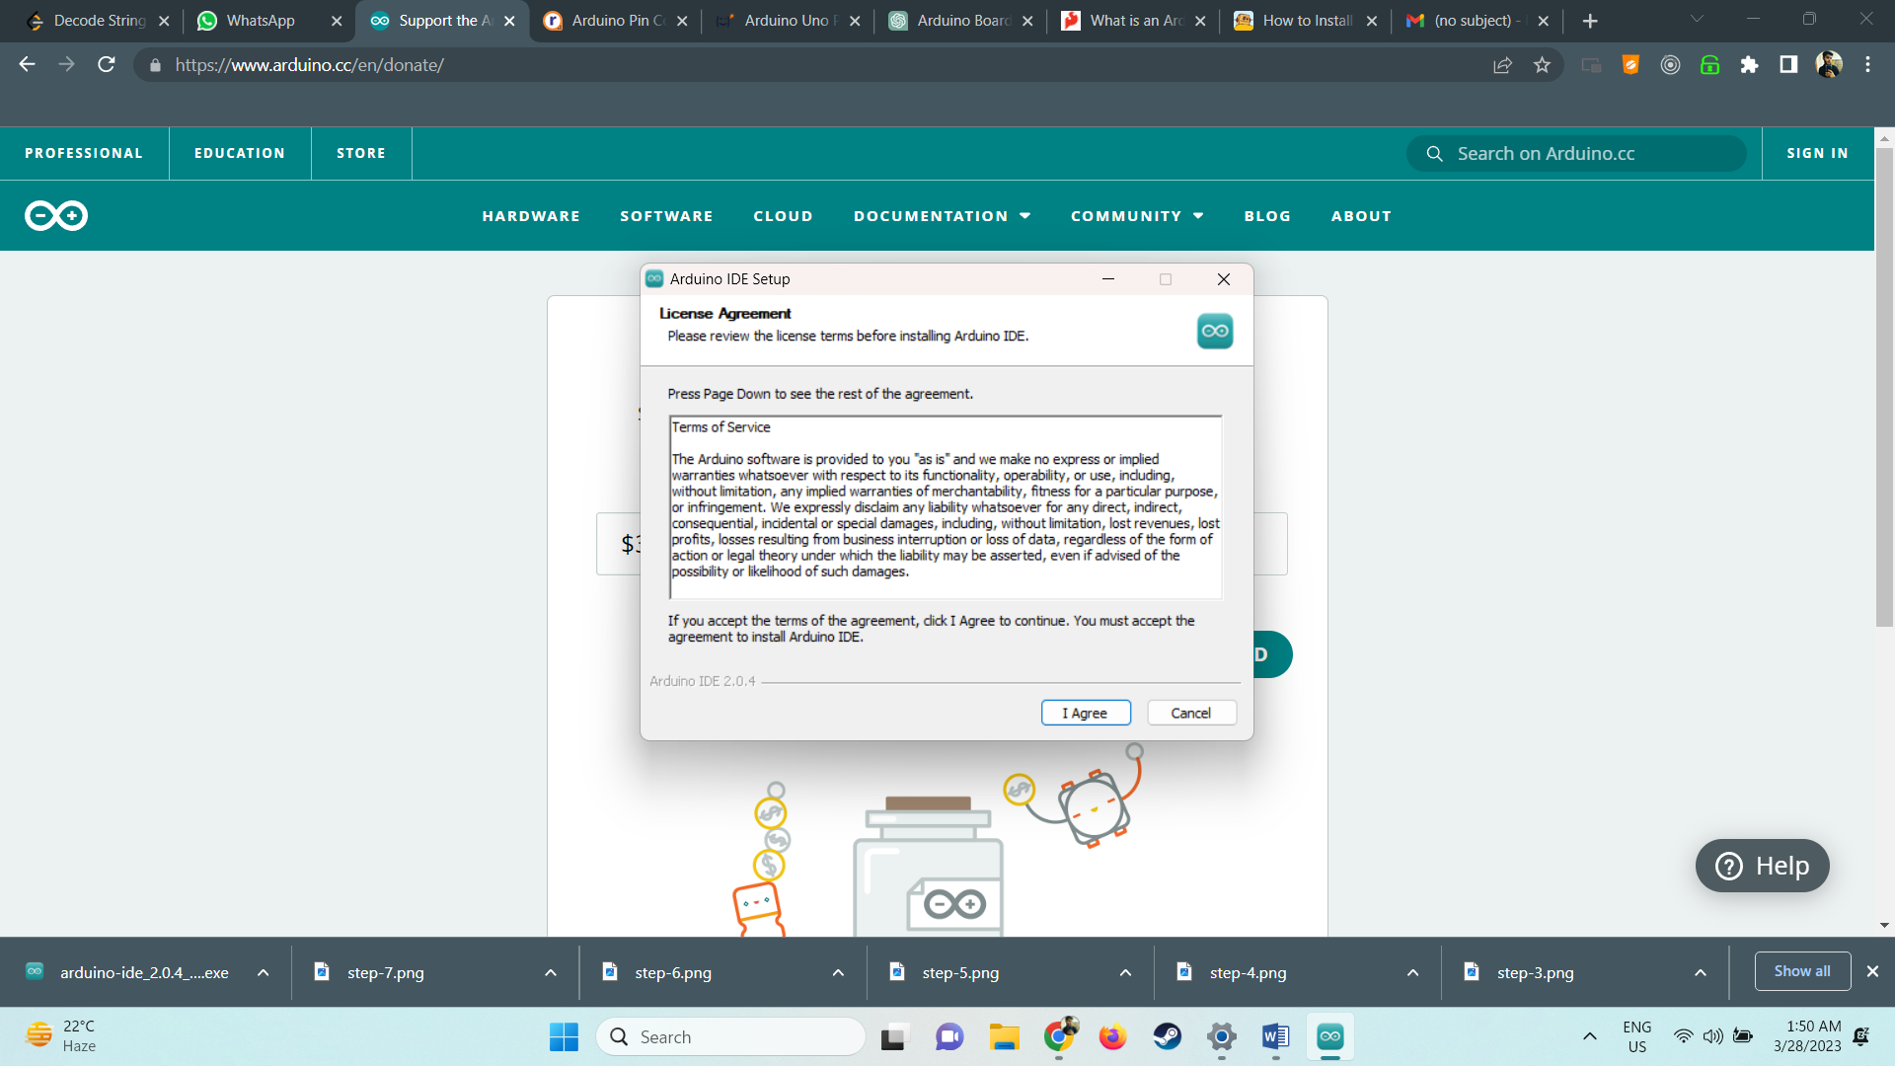

**Step5:-**

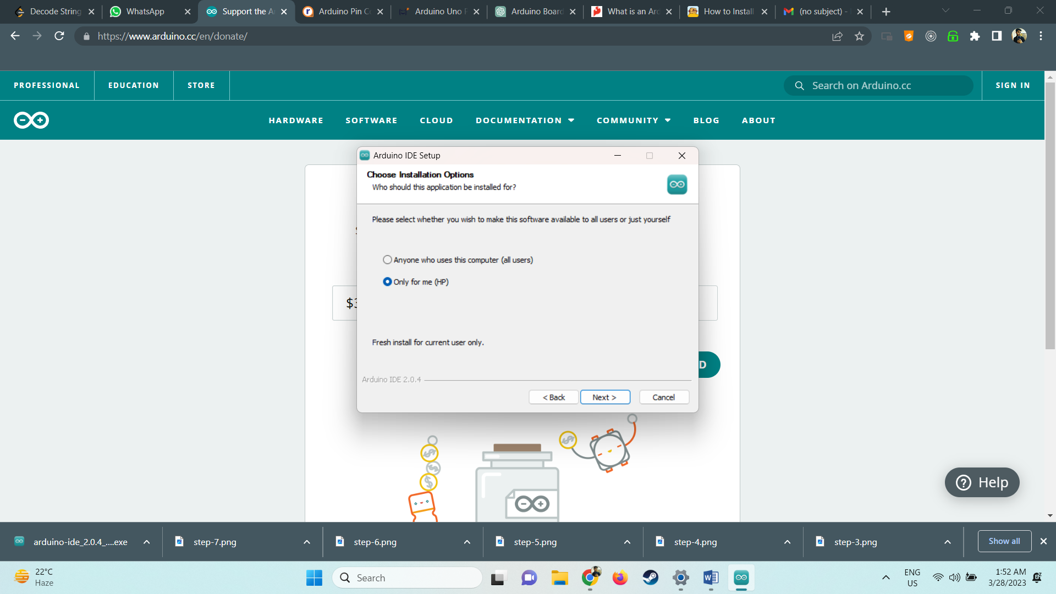

**Step6:-**

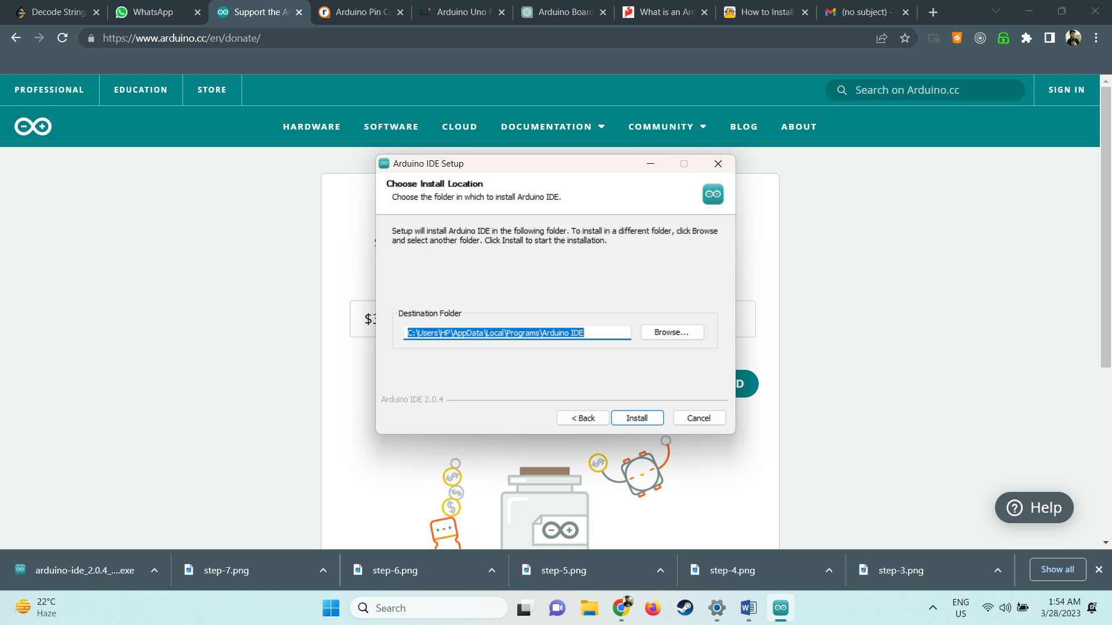

**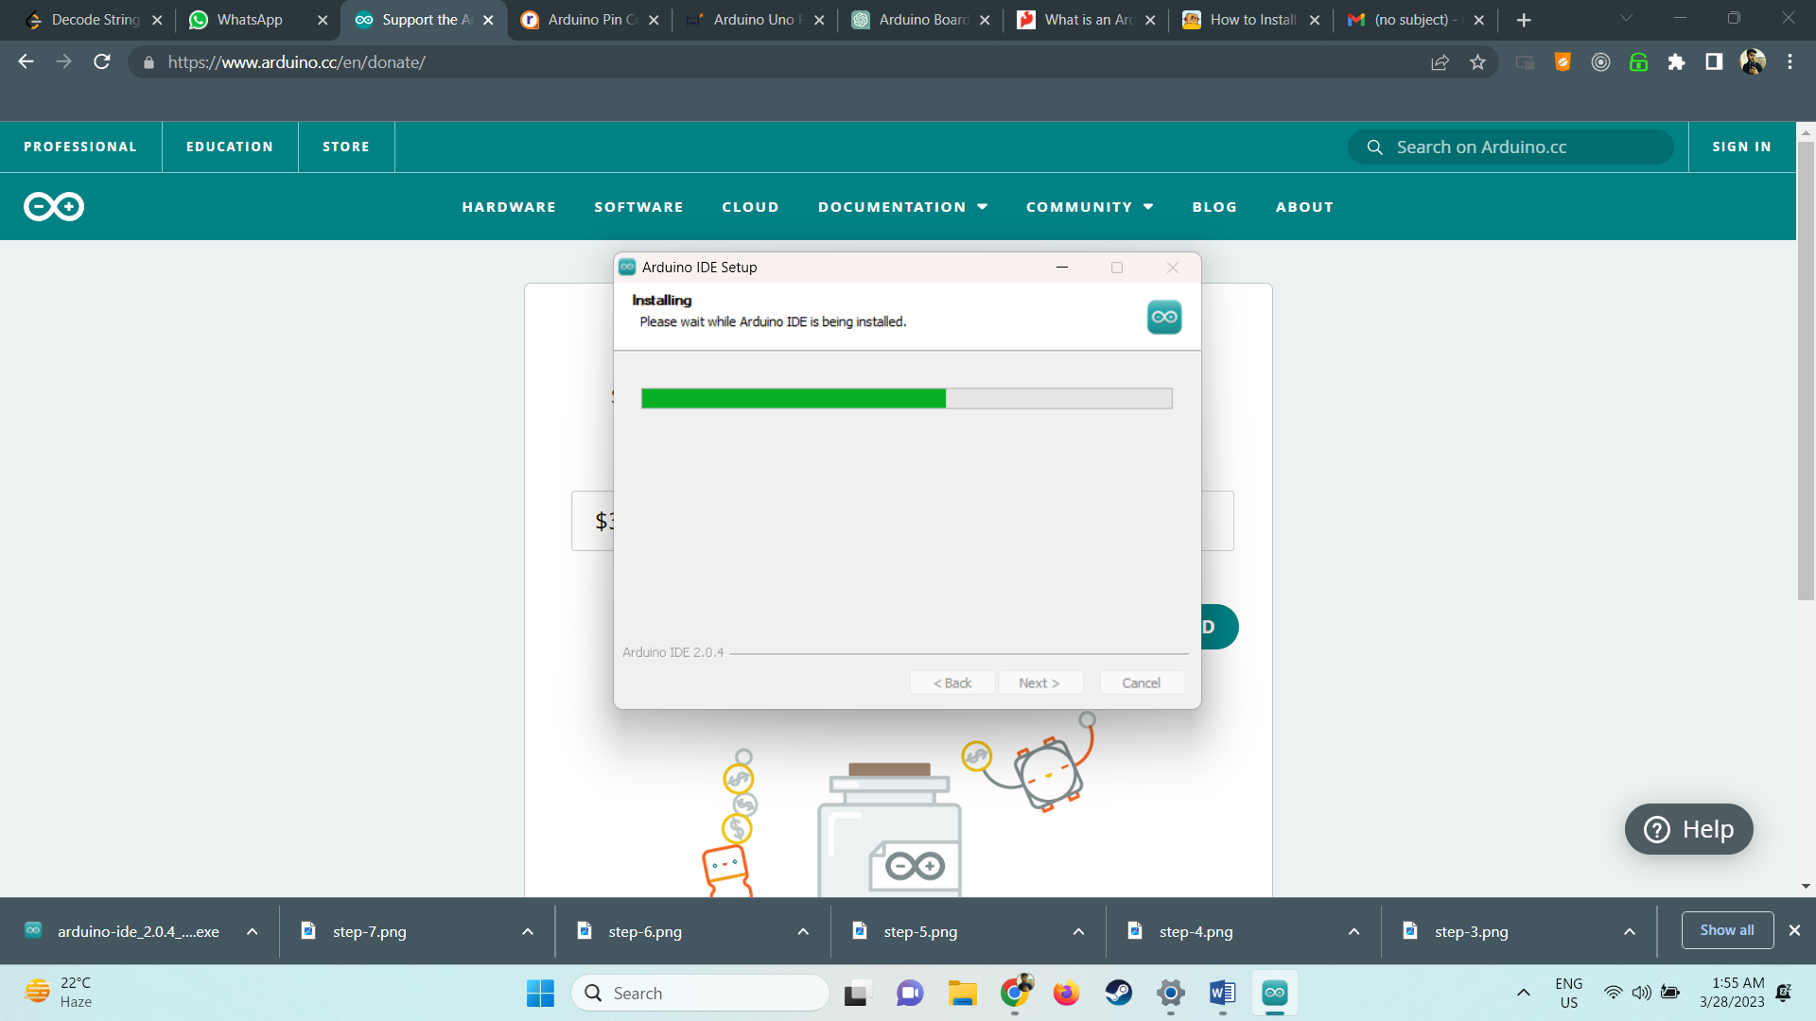Step-7:**

**Step-8:**

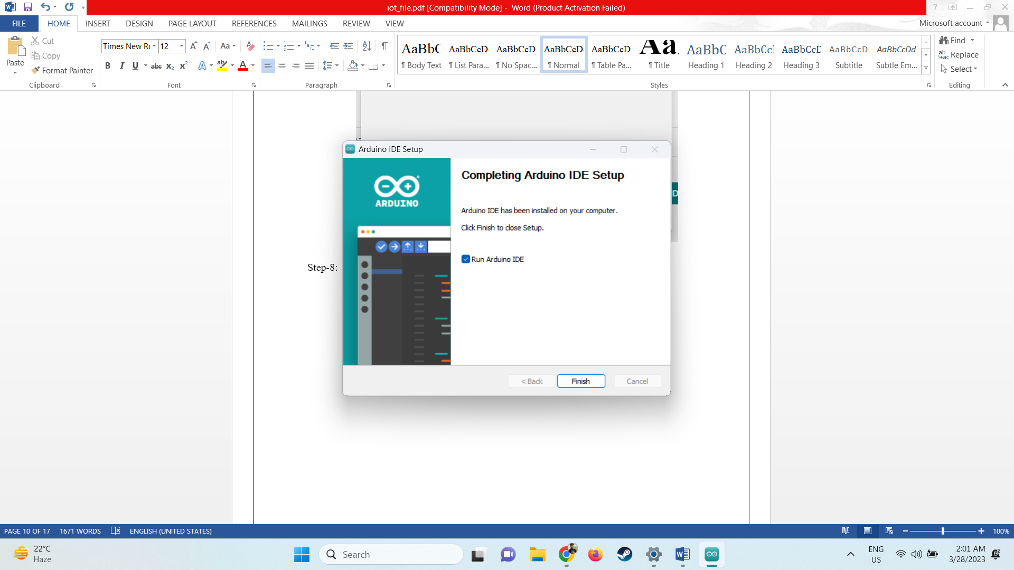

**Step9:-**

# 

# **EXPERIMENT-2**

**AIM** : To interface LED/Buzzer with Arduino/Raspberry Pi and write a program to turn ON LED for Specified seconds

**STEPS:**

1) Download and install tinkercad from **https://www.tinkercad.com/dashboard?type=circuits&collections=designs**

2) Setup the environment

3) From components drag and release the required components :- Arduino ,resistor and LED

4) Connect LED with anode at pin D13 and cathode at pin ground .

5) Connect the resistor one end with 5V supply and another end with D13 pin at Arduino .

6) Now write the code in Code Block .

7) Click on start stimulation .

**CODE :**

void setup()

{

pinMode(2,INPUT);

pinMode(13,OUTPUT);

}

void loop()

{

digitalWrite(13,HIGH);

delay(1000);

digitalWrite(13,LOW);

delay(2000);

}

**IMAGES:-**

**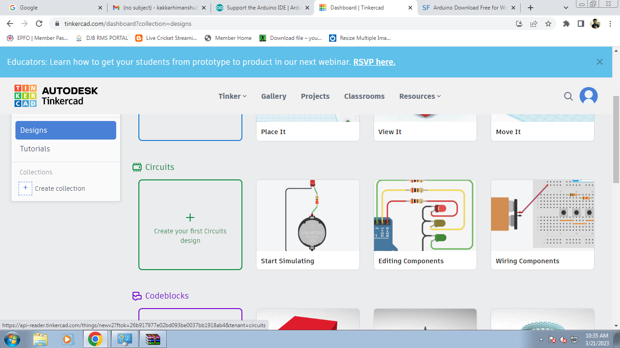Step-1:-**

**Step 2:-**

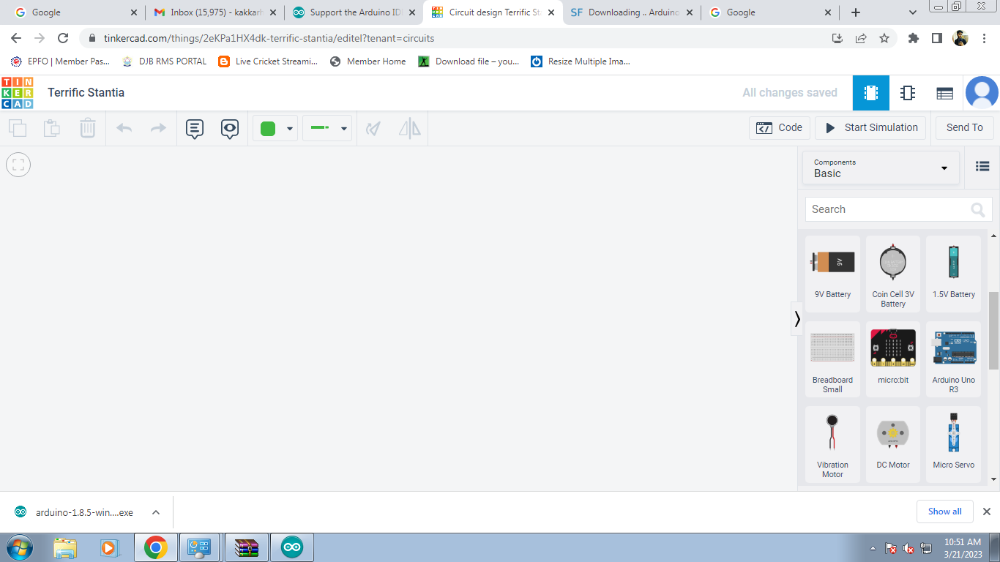

**Step-3 :-**

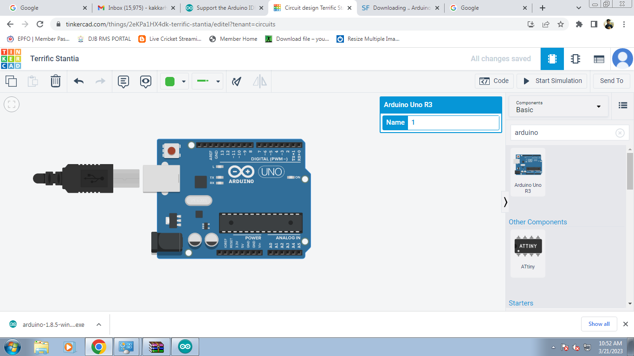

**Step-4:-**

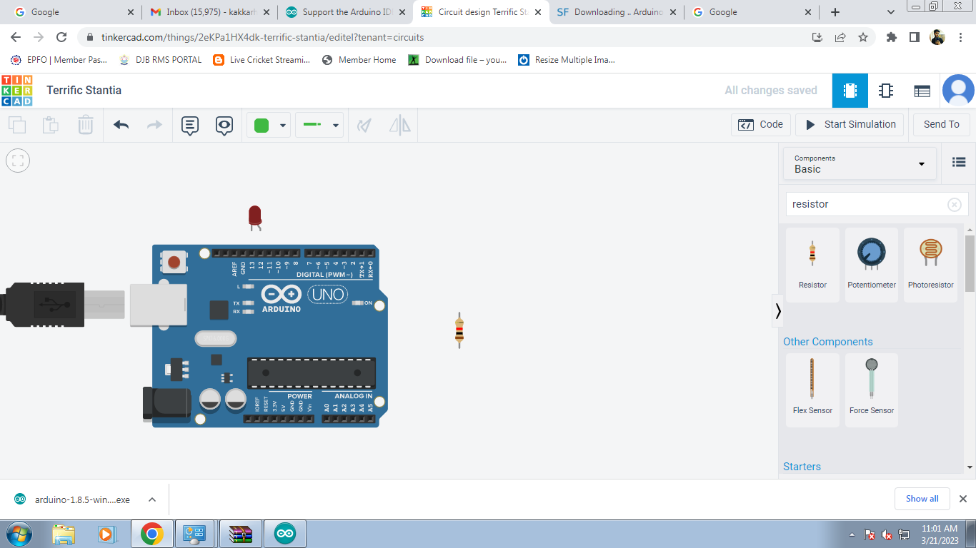

**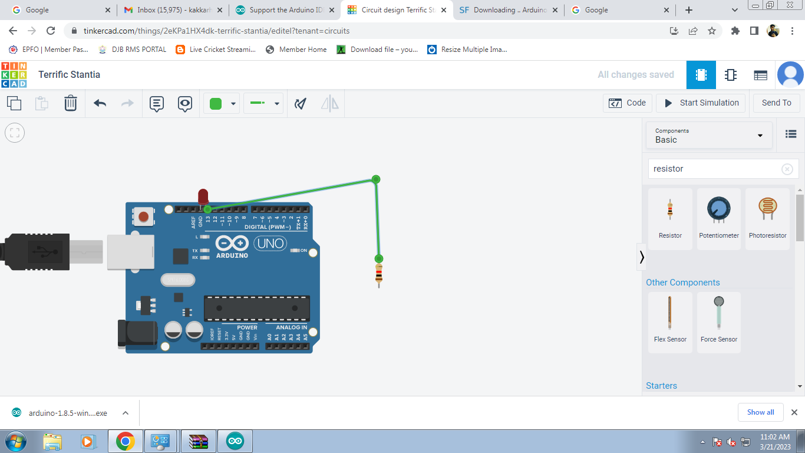Step-5 :-**

**Step-6:-**

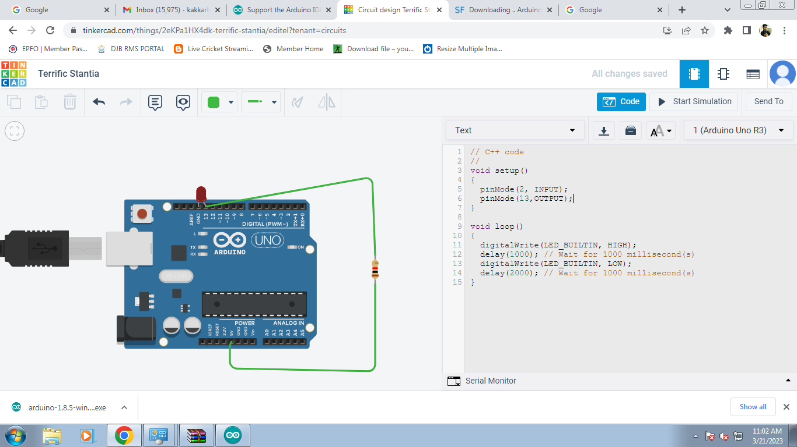

**Result:**

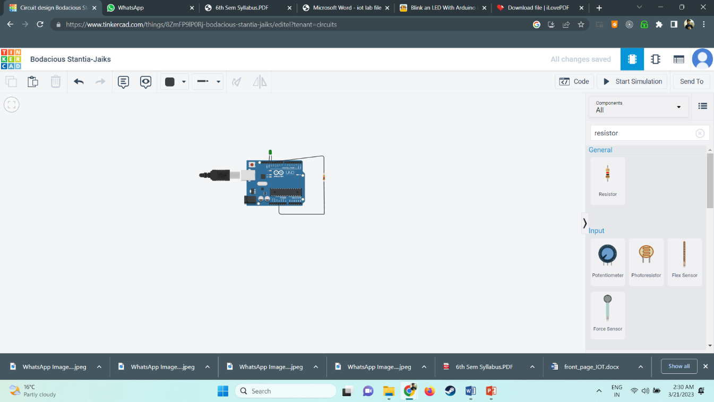

# **EXPERIMENT-3**

**AIM-**  To interface LED/Buzzer with Arduino/Raspberry Pi and write a program to turn ON LED for specified seconds .

**CODE:**

void setup() {

// initialize digital pin LED\_BUILTIN as an output.

pinMode(LED\_BUILTIN, OUTPUT);

}

// the loop function runs over and over again forever

void loop() {

digitalWrite(LED\_BUILTIN, HIGH); // turn the LED on (HIGH is the voltage level)

delay(1000); // wait for a second

digitalWrite(LED\_BUILTIN, LOW); // turn the LED off by making the voltage LOW

delay(1000); // wait for a second

}

**STEPS:-**

1) Plug in your Arduino. Connect your Arduino to the USB port of your computer

2) Launch Arduino IDE. Double-click the icon to start the IDE.

3) To create a new project, select File → New.

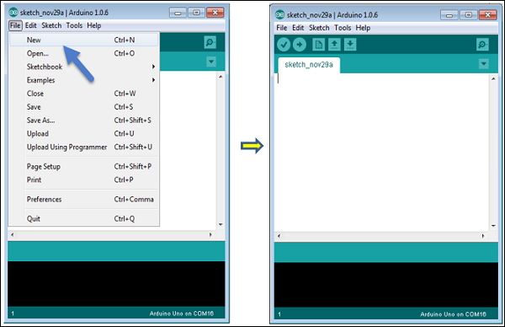

1. Select your Arduino board. To avoid any error while uploading your program to the board, you must select the correct Arduino board name, which matches with the board connected to your computer.

Go to Tools → Board and select your board.

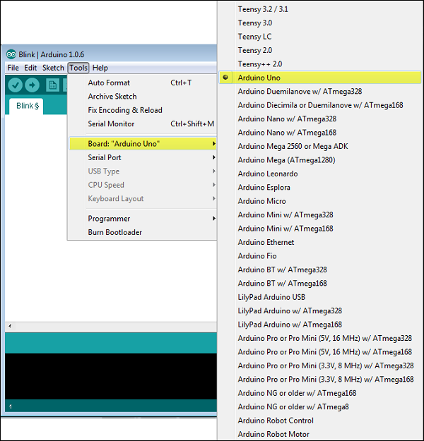

1. Select your serial port. Select the serial device of the Arduino board. Go to Tools → Serial Port menu. This is likely to be COM3 or higher .

# **E:\serial_port.jpg**

1. Upload the program(sketch) to your board.

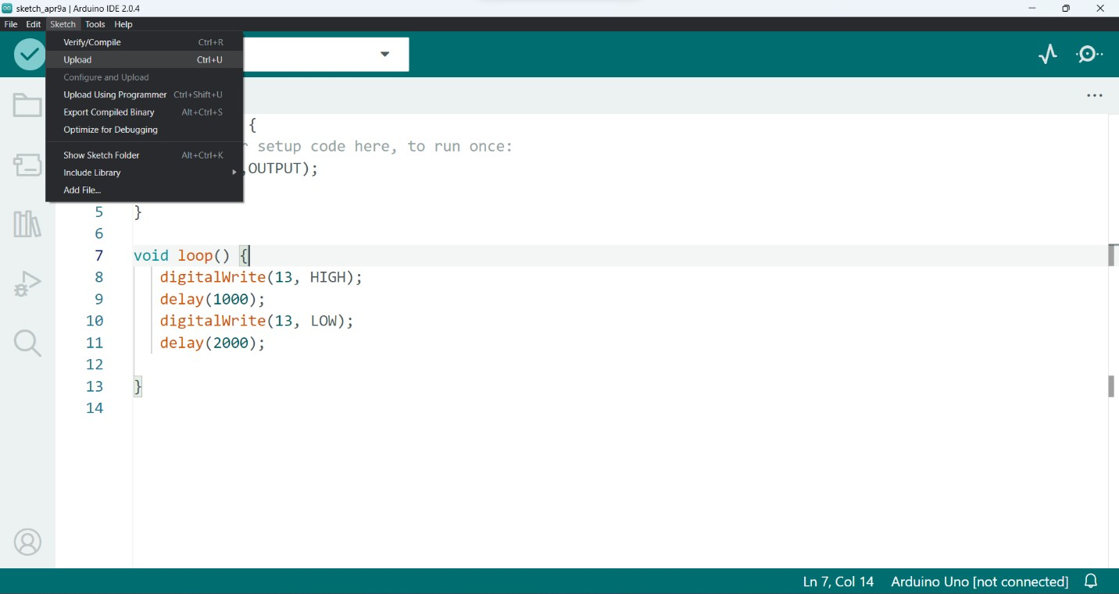

**OUTPUT:**

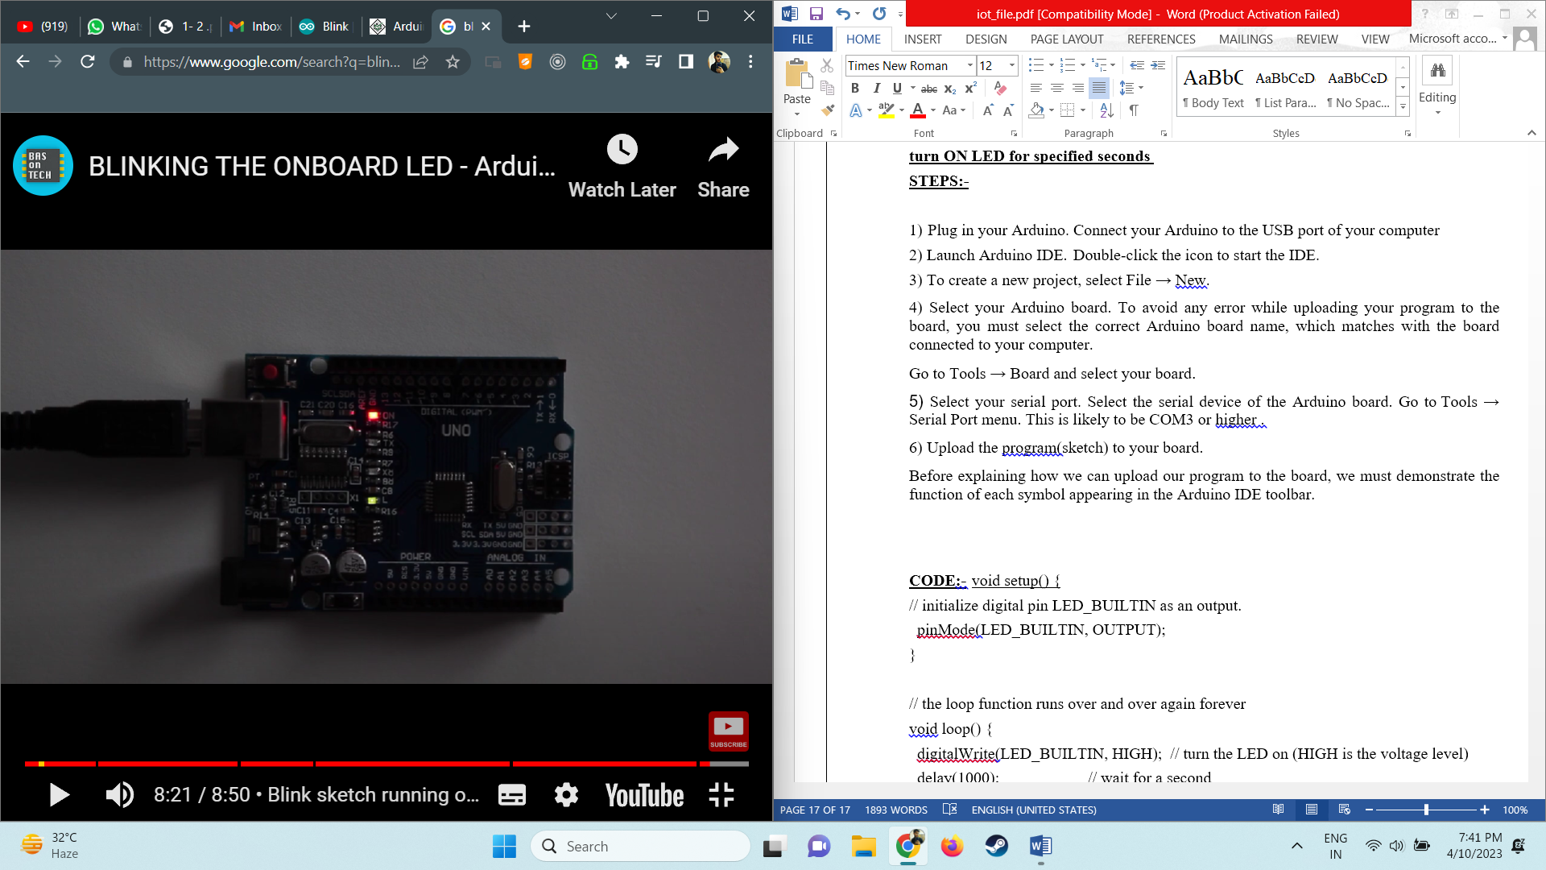

# **EXPERIMENT-4**

**AIM-**  Write a program on Arduino to print Hello World .

**CODE:**

void setup() {

Serial.begin(9600);

}

void loop() {

Serial.println("Hello World!");

delay(1000);

}

**STEPS:-**

1) Plug in your Arduino. Connect your Arduino to the USB port of your computer

2) Launch Arduino IDE. Double-click the icon to start the IDE.

3) Select your Arduino board. To avoid any error while uploading your program to the board, you must select the correct Arduino board name, which matches with the board connected to your computer.

Go to Tools → Board and select your board.



1. Select your serial port. Select the serial device of the Arduino board. Go to Tools → Serial Port menu. This is likely to be COM3 or higher .

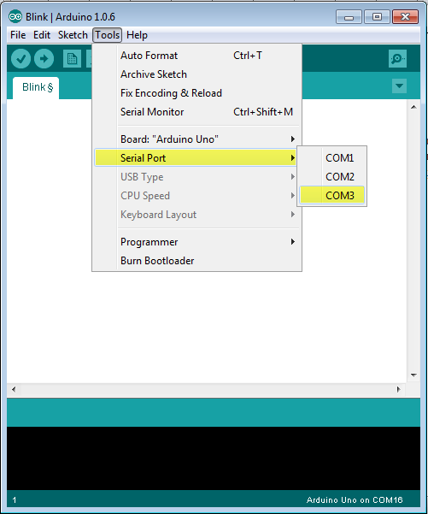

1. Upload the program(sketch) to your board.

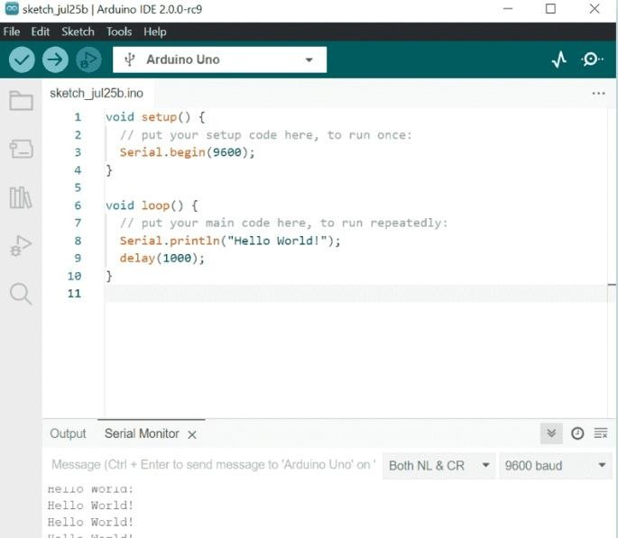

# **OUTPUT:**

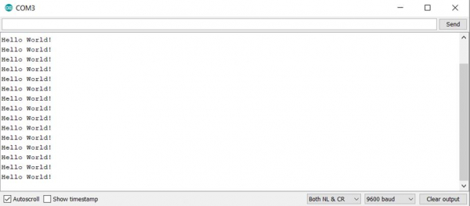

# **EXPERIMENT-5**

**AIM:** Identification of different sensors used in IoT applications. Types of Sensors :-

1. **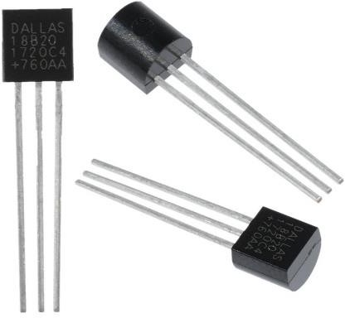Temperature Sensors** : A temperature sensor is a device that detects and measures hotness and coolness and converts it into an electrical signal.
2. 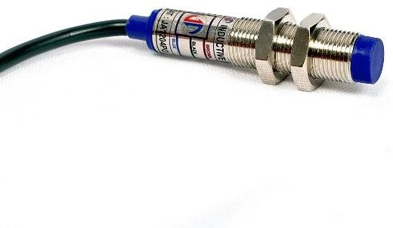**Proximity Sensor**: Proximity Sensor includes all sensors that perform non-contact detection in comparison to sensors, such as limit switches, that detect objects by physically contacting them. Proximity Sensors convert information on the movement or presence of an object into an electrical signal.
3. **Pressure Sensor:** A pressure sensor is defined as a transducer that converts an input mechanical pressure into an electrical output signal (pressure sensor definition). There are several types of pressure sensors based on size, capacity, measurement method, sensing technology and output requirements.

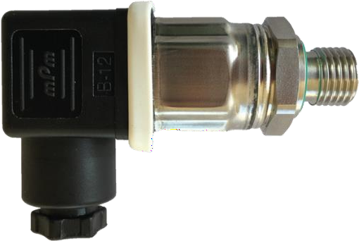

1. **Water Quality Sensor**: These water quality sensors are used in river and stream testing, wastewater measurements, drinking water treatment operations, settling ponds management, sediment transport study and laboratory testing.

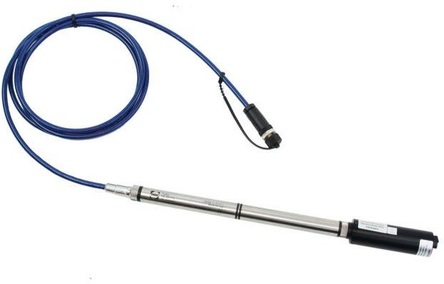

1. **Chemical Sensor** : Chemical sensors are measurement devices that convert a chemical or physical property of a specific analyte into a measurable signal, whose magnitude is normally proportional to the concentration of the analyte.

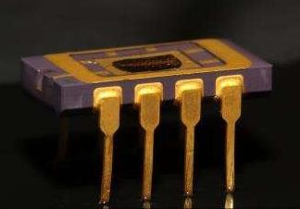

1. **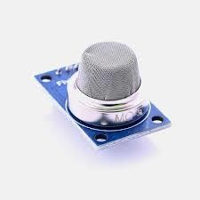Gas Sensor** : Gas sensors (also known as gas detectors) are electronic devices that detect and identify different types of gasses. They are commonly used to detect toxic or explosive gasses and measure gas concentration.

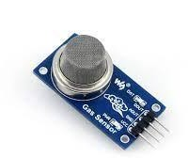

1. **Smoke Sensor** : A smoke detector is an electronic fire-protection device that automatically senses the presence of smoke, as a key indication of fire, and sounds a warning to building occupants. Commercial and industrial smoke detectors issue a signal to a fire alarm control panel as part of a building's central fire alarm system.
2. **IR sensor** : IR sensors are now widely used in motion detectors, which are used in building services to switch on lamps or in alarm systems to detect unwelcome guests. In a defined angle range, the sensor elements detect the heat radiation (infrared radiation) that changes over time and space due to the movement of people.

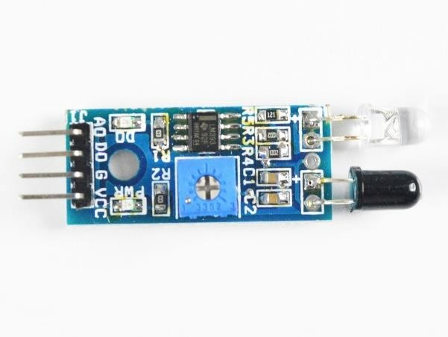

1. **Level Sensor** : A level sensor is a device that is designed to monitor, maintain, and measure liquid (and sometimes solid) levels. Once the liquid level is detected, the sensor converts the perceived data into an electric signal.

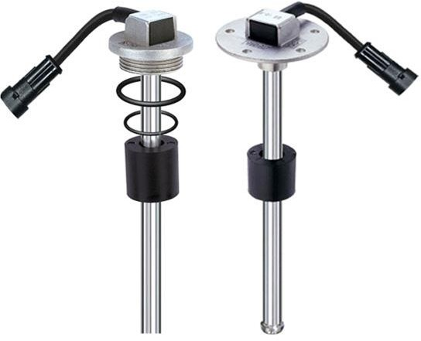

1. **Image Sensor** : What is image sensor in IOT? Image result for Image sensor Known as the 'eyes of machines', an image sensor is a core device for a variety of applications. These applications can range from robotics to drones, requiring image sensors to offer different characteristics and features.

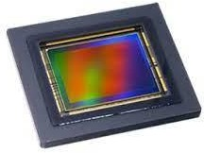

1. 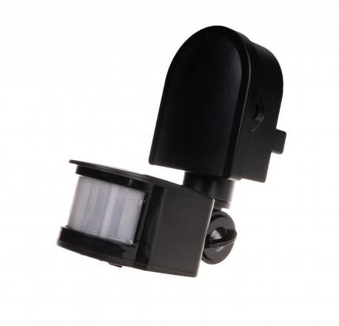 **Motion Detector Sensor:** A motion sensor (or motion detector) is the linchpin of your security system because it detects when someone is in your home when they shouldn't be. A motion sensor uses one or multiple technologies to detect movement in an area.
2. **Accelerometer Sensor** : An accelerometer sensor is a tool that measures the acceleration of any body or object in its instantaneous rest frame. It is not a coordinate acceleration. Accelerometer sensors are used in many ways, such as in many electronic devices, smartphones, and wearable devices, etc.

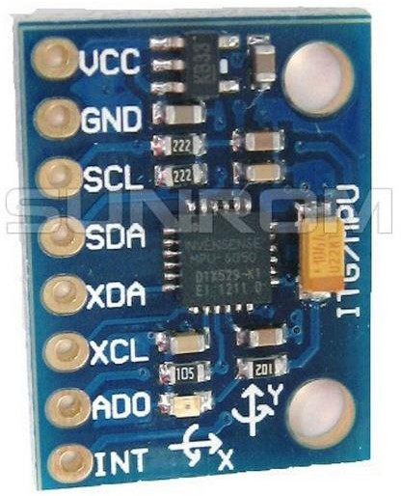

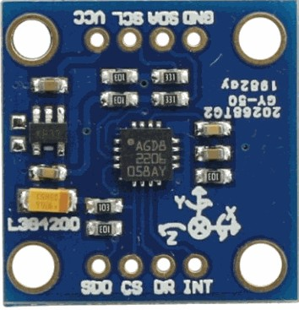

1. **Gyroscope Sensor** : A gyroscope is a device that uses Earth's gravity to help determine orientation. Gyro sensors are devices that sense angular velocity which is the change in rotational angle per unit of time. Angular velocity is generally expressed in deg/s (degrees per second).
2. **Humidity Sensors** : A humidity sensor is a device that detects and measures water vapor. TE Connectivity (TE) manufactures a complete range of calibrated and amplified RH sensor products to measure relative humidity.

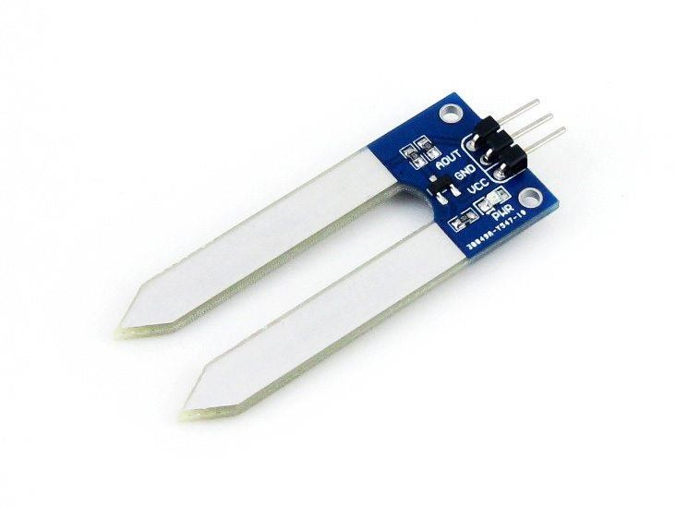

1. **Optical Sensors** : Optical sensors can be used for a broad range of applications ranging from simple detection of distance to providing artificial vision to a system for object recognition. Infrared sensors can also be used to detect distances based on the detection of modulated light.

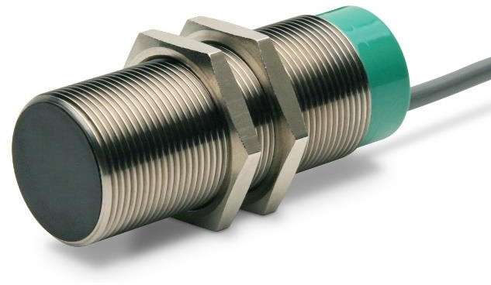

**EXPERIMENT-6**

**AIM :** To interface LED/Buzzer with Arduino/Raspberry Pi and write program to turn ON LED for 1 sec after every 2 seconds.

**MATERIAL REQUIRED:** Arduino micro-controller, USB Connector, Computer.

**CODE :**

void setup() {

pinMode(LED\_BUILTIN, OUTPUT);

}

void loop() {

digitalWrite(LED\_BUILTIN, HIGH);

delay(1000); // wait for a second

digitalWrite(LED\_BUILTIN, LOW);

delay(1000);

}

**Procedure:**

1. 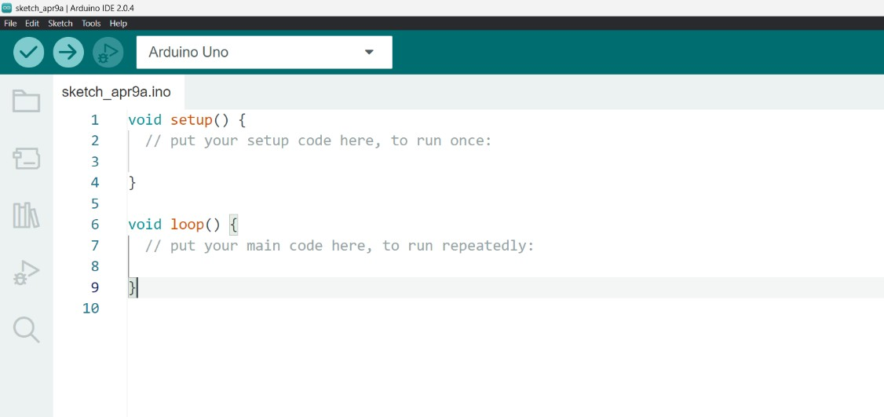Open Arduino IDE
2. Select board and port to which the Arduino Board is connected.

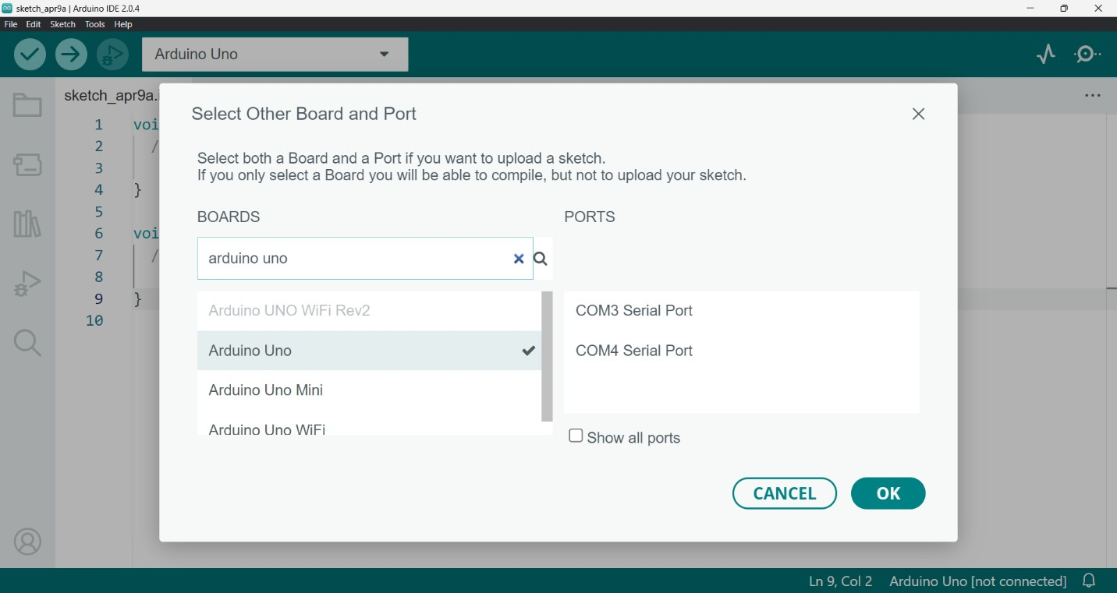

1. Write the code to to turn ON LED for 1 sec after every 2 seconds.

**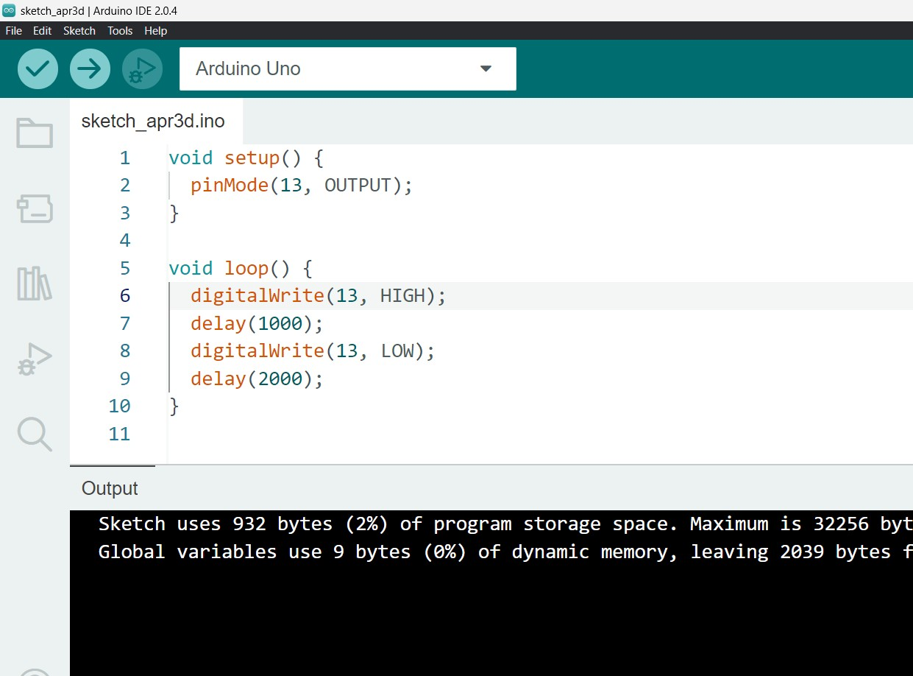**

1. 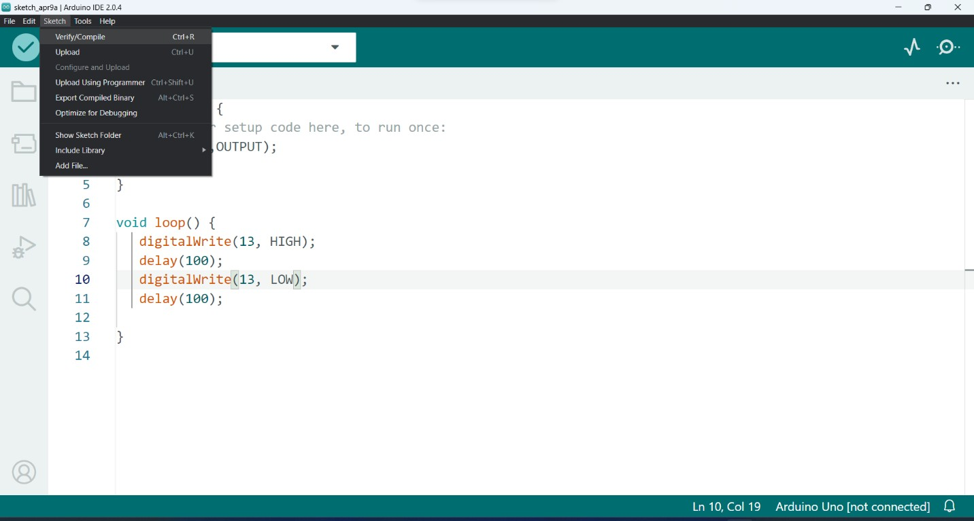Click on sketch tab then select verify/ compile or press Ctrl + R.
2. Click on sketch tab then select upload or press Ctrl + U.

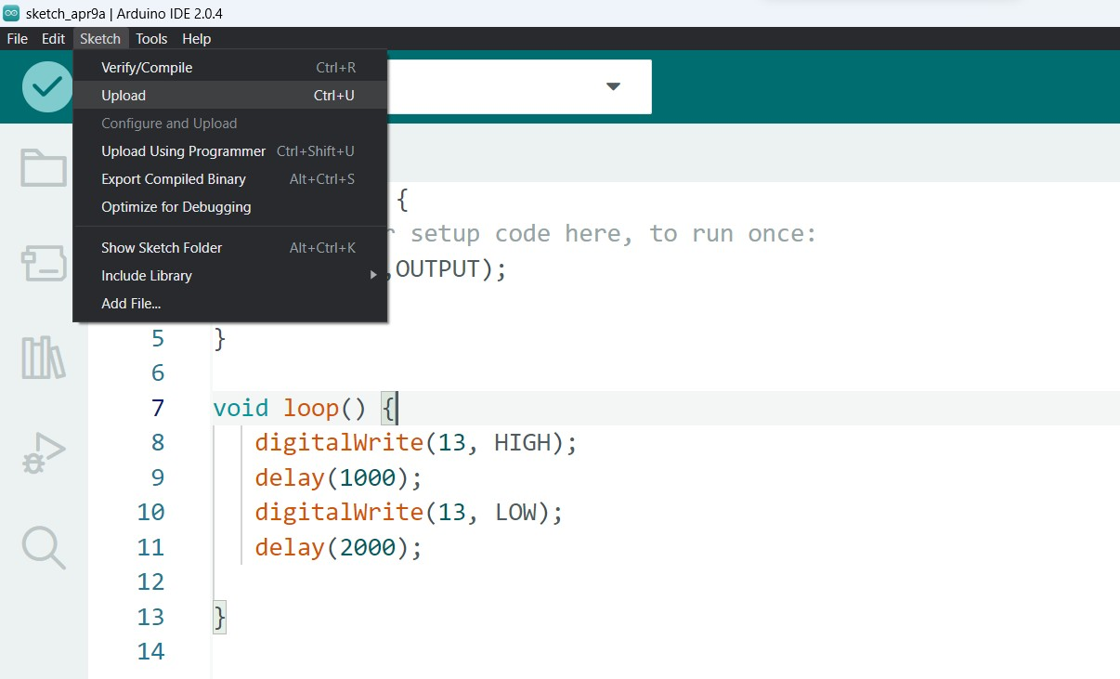

1. Check the output on Arduino board.

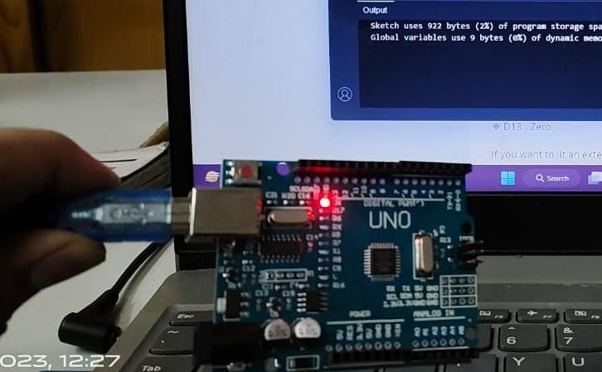

**RESULT:** The in-built LED of Arduino board starts blinking.

**EXPERIMENT-7**

**AIM :** To demonstrate LED blinking using push button on Arduino /uno

**MATERIAL REQUIRED:** Arduino micro-controller, USB Connector, Computer.

**CODE :**

void setup() {

pinMode(2,INPUT);

pinMode(13,OUTPUT);

}

void loop() {

if(digitalRead(2)==HIGH)

{

  digitalWrite(13,HIGH);

}

else{

digitalWrite(13,LOW);}

}

**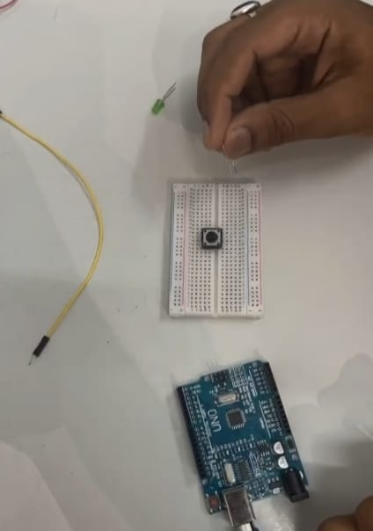**

**Procedure:**

1. Insert Push Button in Breadboard.
2. 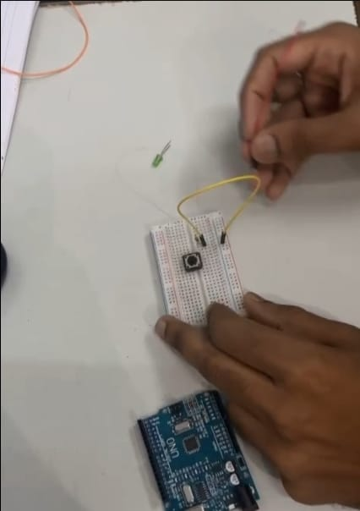Connect one legs of push button with resistor and another with ground.

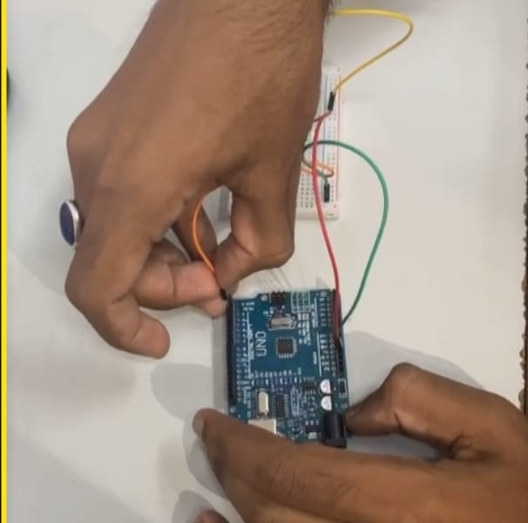

1. Connect One Leg of Push button to the pin2 or Digital Read of the Arduino Uno & connect Ground of breadboard with ground pin of Arduino Uno.

.

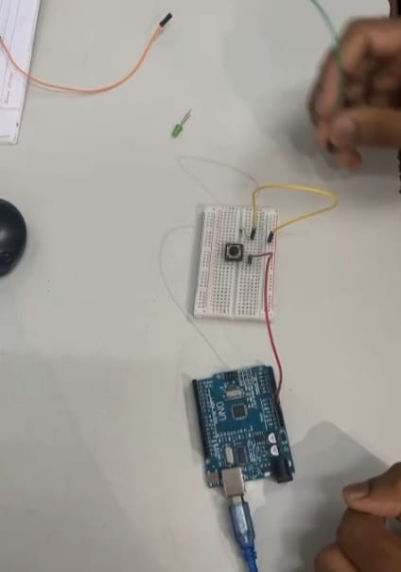

1. 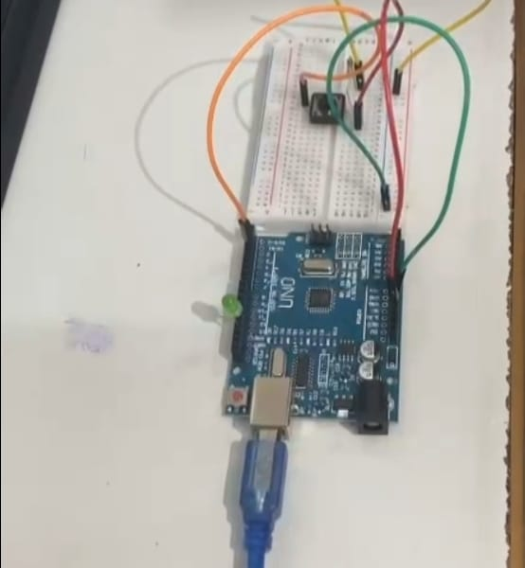Connect the Cathode of LED with ground and anode of LED with the 13th pin or the output pin .
2. Our Circuit is ready . Now we have to setup our IDE .

Open Arduino IDE and type the porgramming code for “LED blinking using push button” , Compile it and Save it .

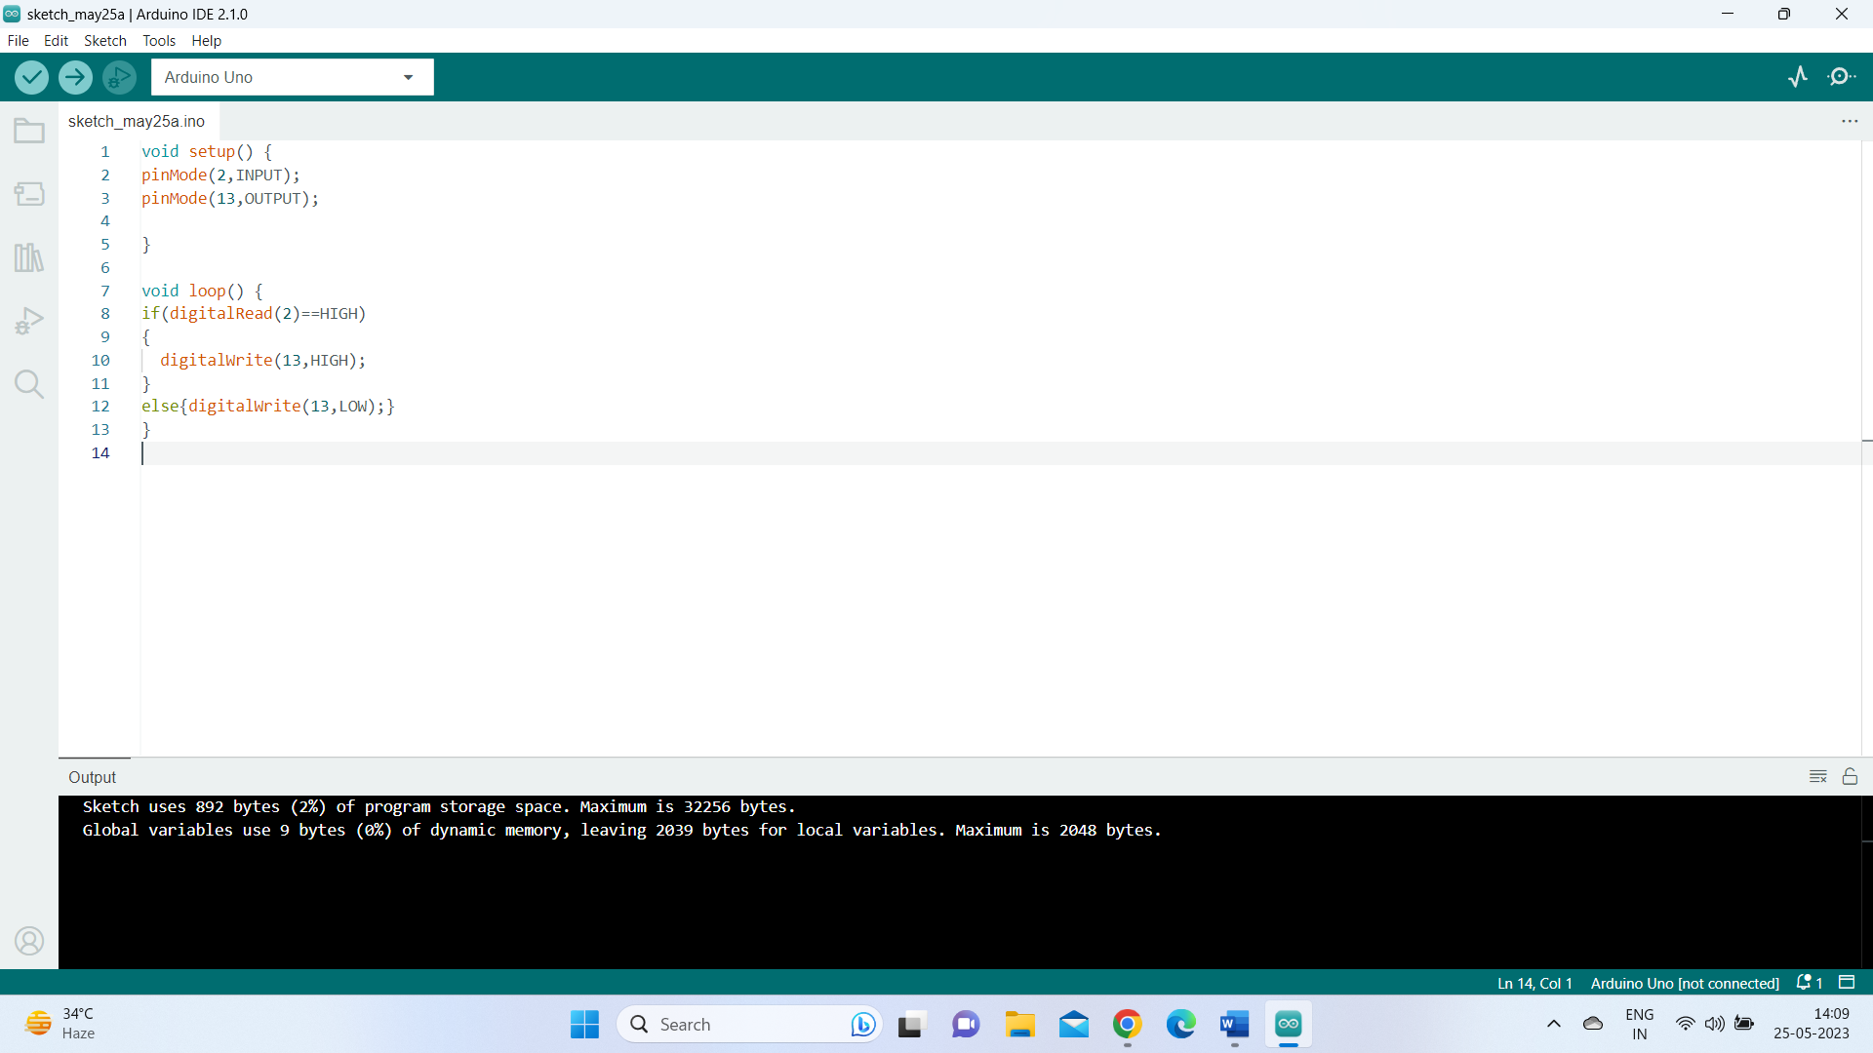

1. Connect Arduino with your PC and select the port and Board you are using.



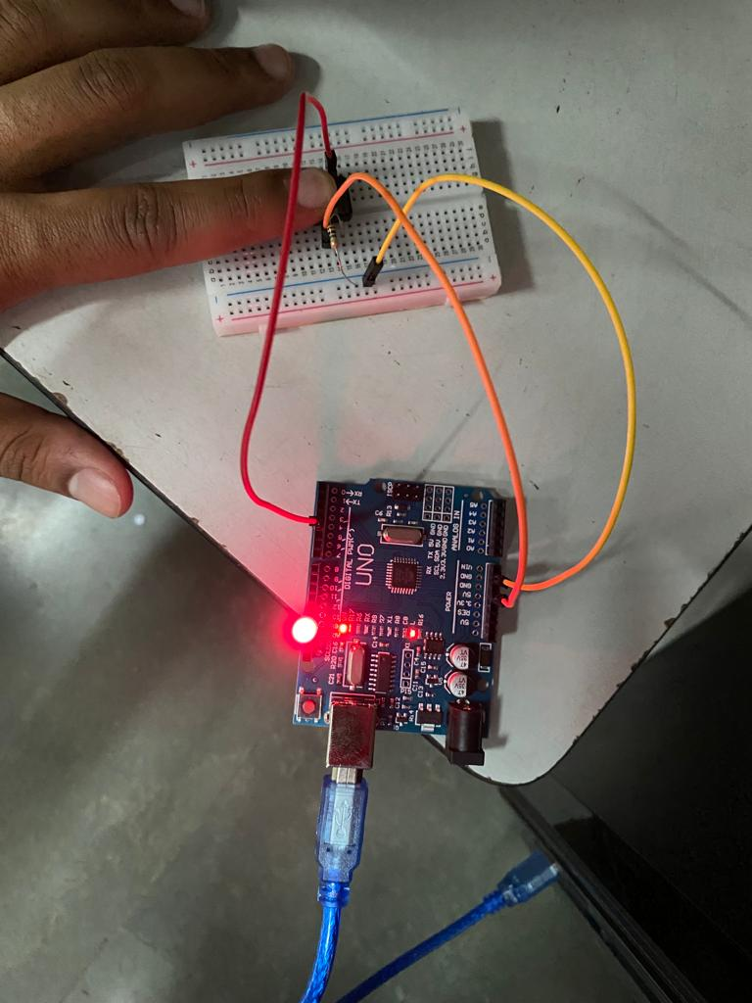

1. Upload the code in Your device and now press the push button .

**RESULT:** The LED of Breadboard starts blinking on the press of push button.

**EXPERIMENT-8**

**AIM :** To interface Bluetooth with Arduino/Raspberry Pi and write a program to turn LED ON/OFF when ‘1’/’0’ is received from smartphone using Bluetooth .

**MATERIAL REQUIRED:** Arduino micro-controller, USB Connector, Computer, Smartphone, Led, Bluetooth sensor hc-05, Male to Female connector wires.

**CODE :**

char Incoming\_value = 0;

void setup() {

Serial.begin(9600);

pinMode(13,OUTPUT);

}

void loop()

{

if(Serial.available() > 0)

{

Incoming\_value = Serial.read();

Serial.print(Incoming\_value);

Serial.print("\n");

if(Incoming\_value == '1')

digitalWrite(13, HIGH);

else if(Incoming\_value == '0')

digitalWrite(13,LOW);

}

}

**Procedure:**

1. Connect the Bluetooth sensor HC-05 to the Arduino Board. It has 6 pins, and we will leave the two pins unused. Connect the 1st pin to the power supply and the other pin to the ground. Connect the Rxd pin of the Bluetooth sensor to the TXD pin of the Arduino, and connect the Txd pin of the sensor to the Rxd pin of the Arduino.

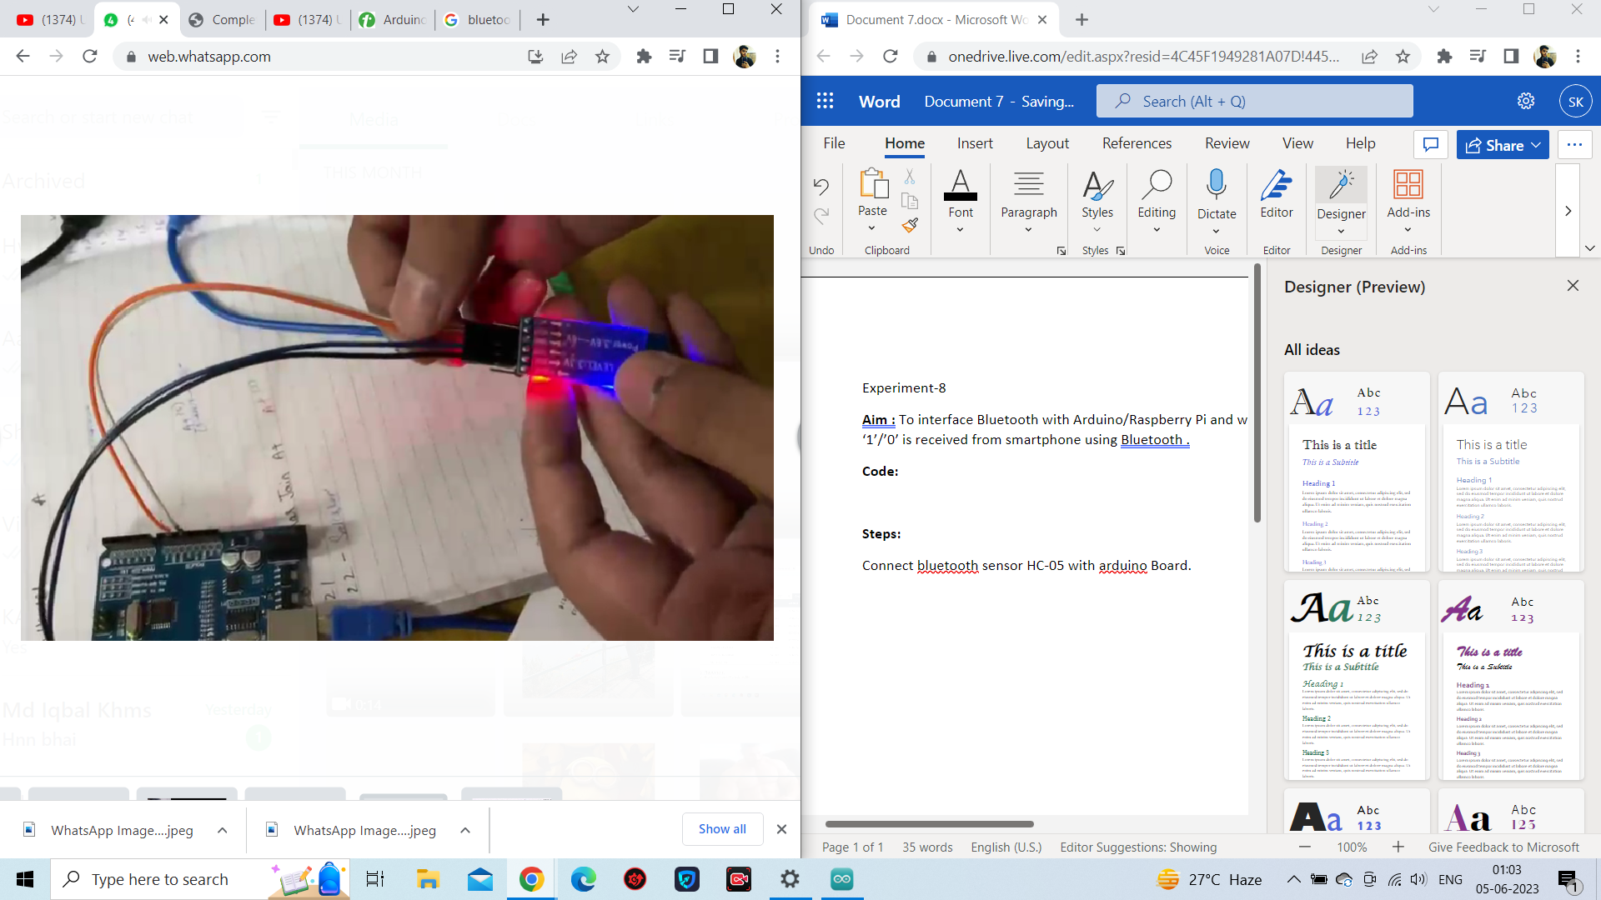

1. Connect the LED to the Arduino Board. Connect the anode of the LED to the 13th pin of the Arduino and the cathode to the ground.

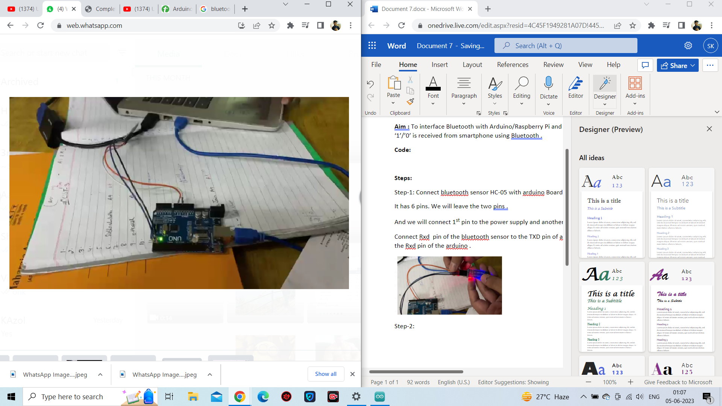

1. Connect the Arduino to the PC and type the above-written code.

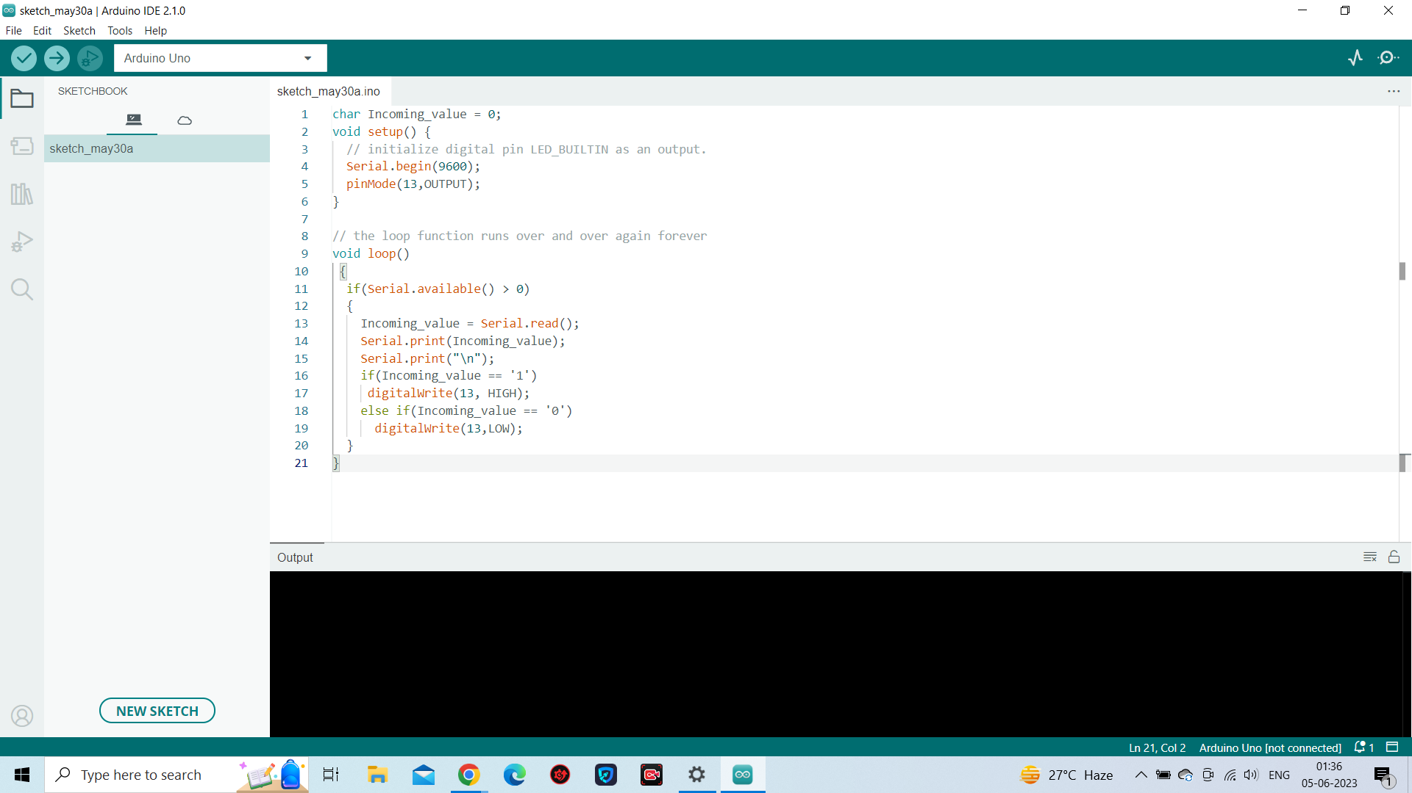

1. Before compiling and uploading the code, we need to create an app for our Smartphone. This app will allow us to control LED blinking directly from our Smartphone using a GUI application. Head over to MIT App Inventor and create an app using various loops, procedures, and control blocks.

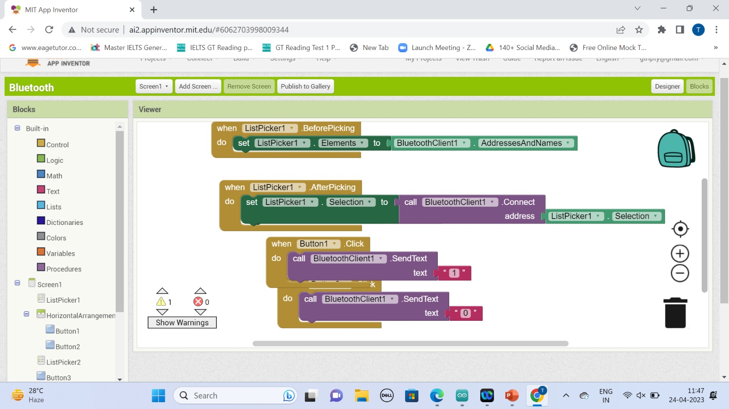

1. Download the .apk file for your smartphone by scanning the QR Code.

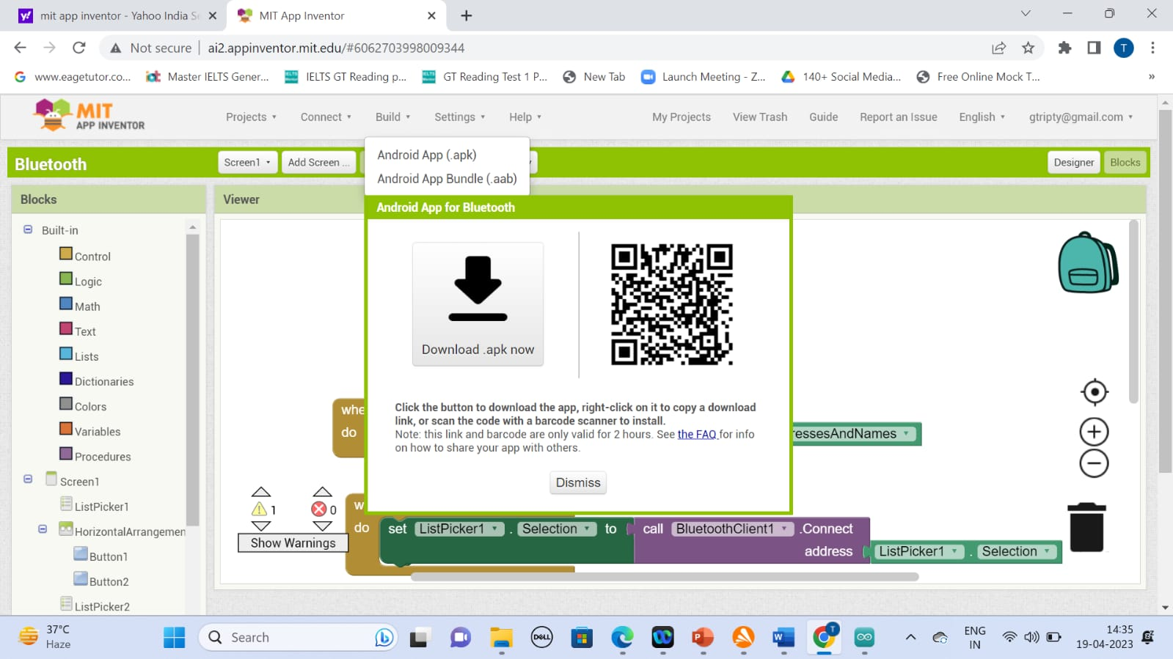

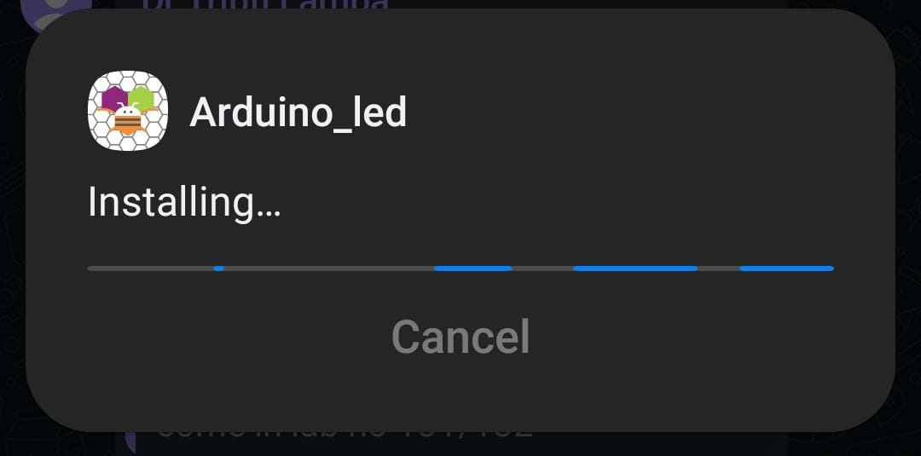

1. Install the APK on the smart phone from which you want to control the LED blinking, and connect your phone's Bluetooth with the Bluetooth sensor.
2. Verify , Compile and Upload code in arduino .

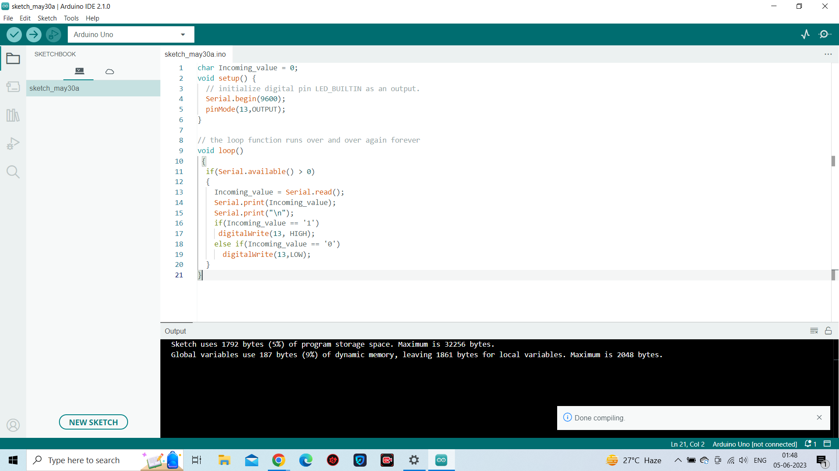

1. After successfully connecting to the Bluetooth sensor, open the installed application and press the "on" button.

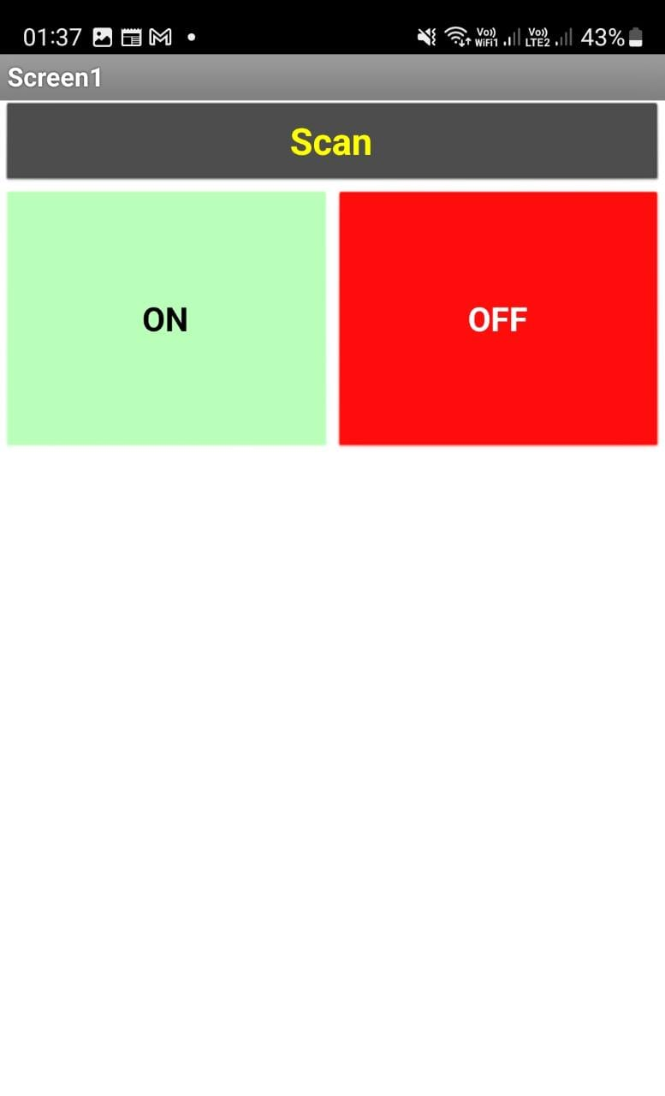

**RESULT:** The LED connected to the Arduino pins turns on when the push button is pressed via the smartphone using Bluetooth.

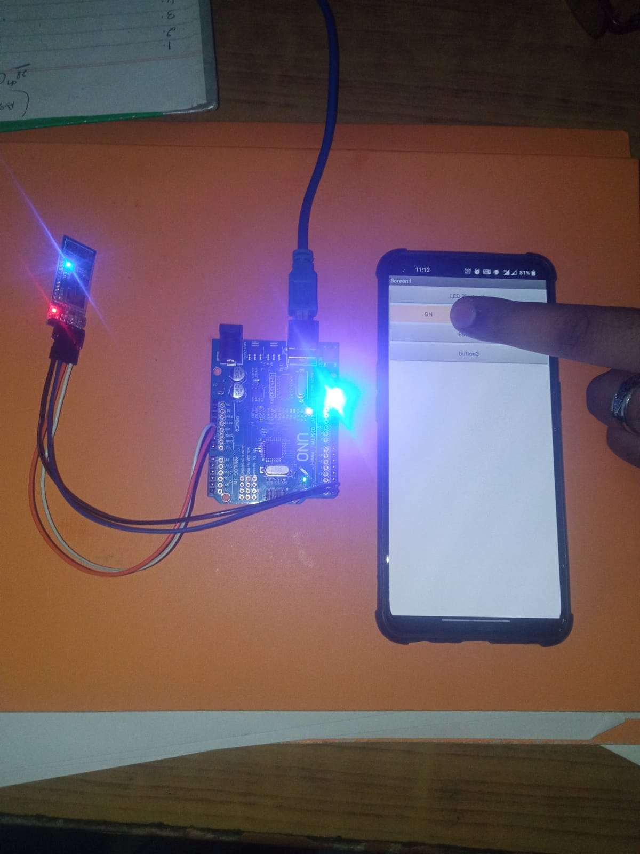

**EXPERIMENT-9**

**AIM :** To interface DHT11 sensor with ARDUINO and write a program to measure temperature and humidity of the surroundings.

**MATERIAL REQUIRED:** Arduino micro-controller, USB Connector, Computer, Smartphone, LED, DHT11 sensor, Male to Female connector wires.

**CODE :**

#include <DHT.h>

#include <DHT\_U.h>

#define DHTPIN 3

#define DHTTYPE DHT11

DHT dht(DHTPIN, DHTTYPE);

void setup() {

Serial.begin(9600);

Serial.println("DHTxx test!");

dht.begin();

}

void loop() {

delay(2000);

float h = dht.readHumidity();

float t = dht.readTemperature();

float f = dht.readTemperature(true);

if (isnan(h) || isnan(t) || isnan(f)) {

Serial.println("Failed to read from DHT sensor!");

return;

}

Serial.print("Humidity: ");

Serial.print(h);

Serial.print(" %\t");

Serial.print("Temperature: ");

Serial.print(t);

Serial.print(" \*C ");

Serial.print(f);

Serial.print(" \*F\t");

Serial.println("");

}

**Procedure:**

1. Open the Arduino IDE, go to Sketch, manage libraries, and import the DHT11 library. Then add this library, along with the Adafruit library, to your code.

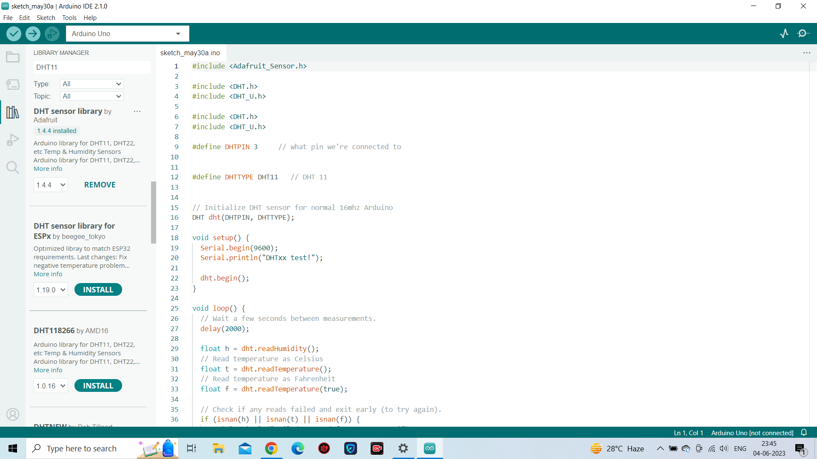

1. Connect the DHT sensor to the Arduino Uno. One leg of the sensor should be connected to the power supply (5V), another leg to the ground, and the third leg to the Arduino pin where we will receive the output. These connections can be made using male-female connector wires.

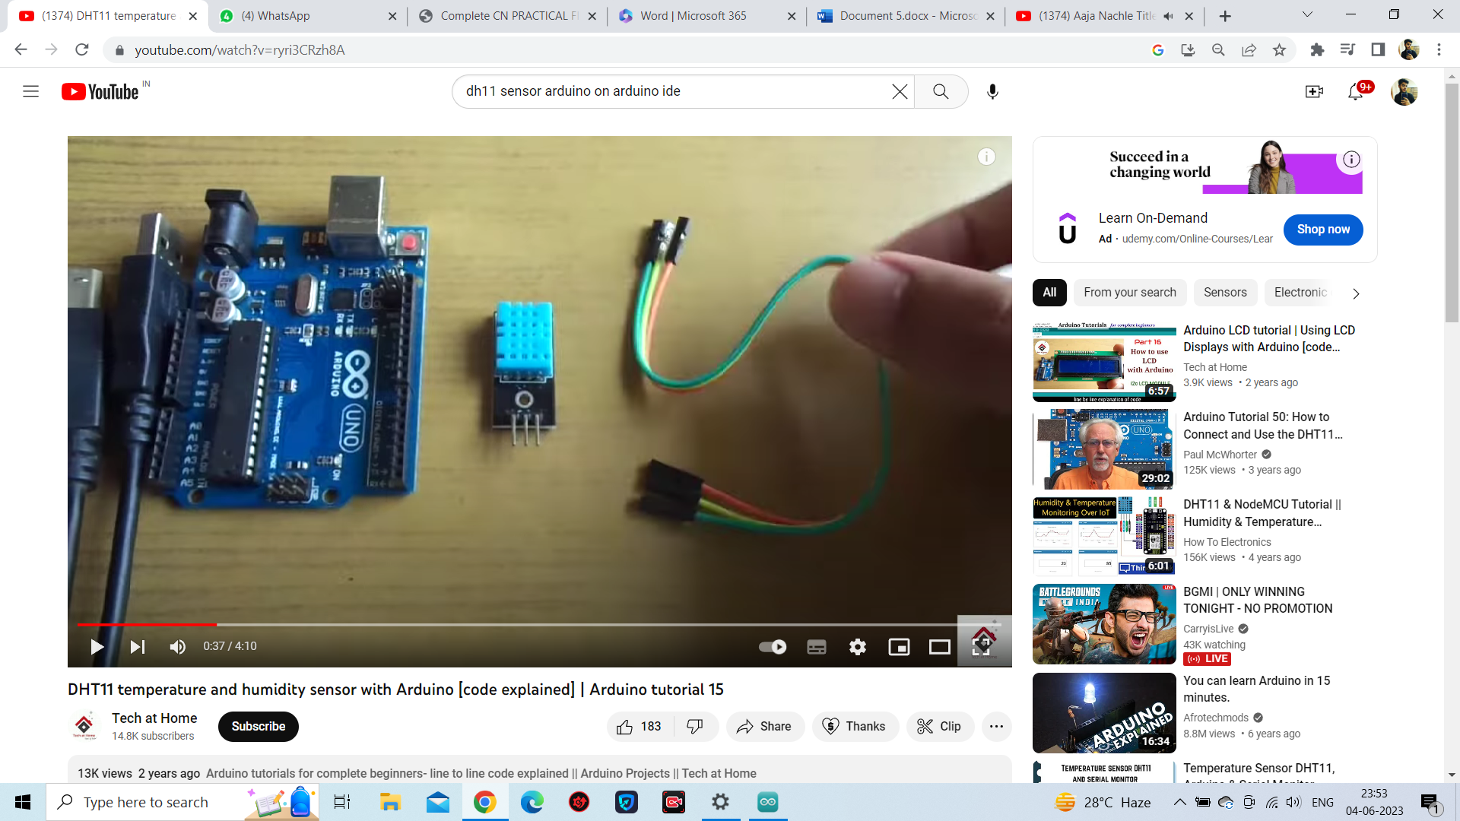

1. Now connect the Arduino Board to your laptop or PC. Select the Arduino Board from the Boards section in Arduino Uno and choose the Port through which it is connected.

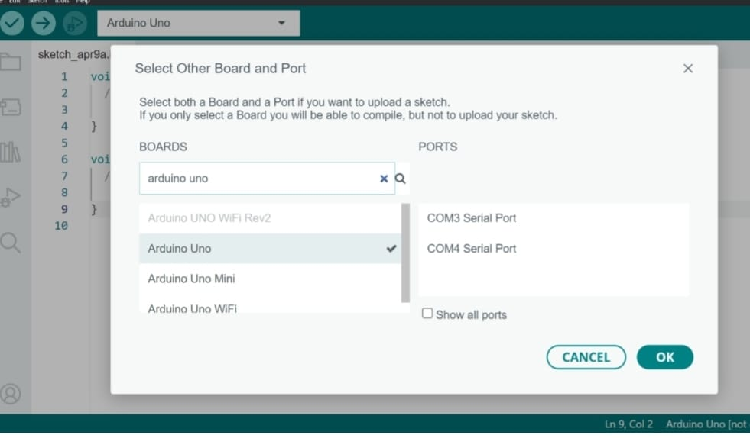

1. Then write down the code for the DHT11 sensor to measure temperature and humidity, and store the readings in the float data type.

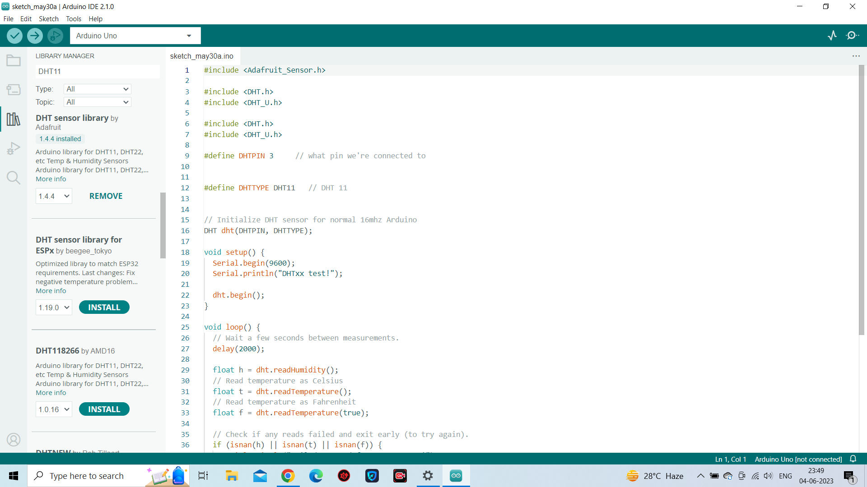

1. Verify , Compile and Upload the program to Arduino.

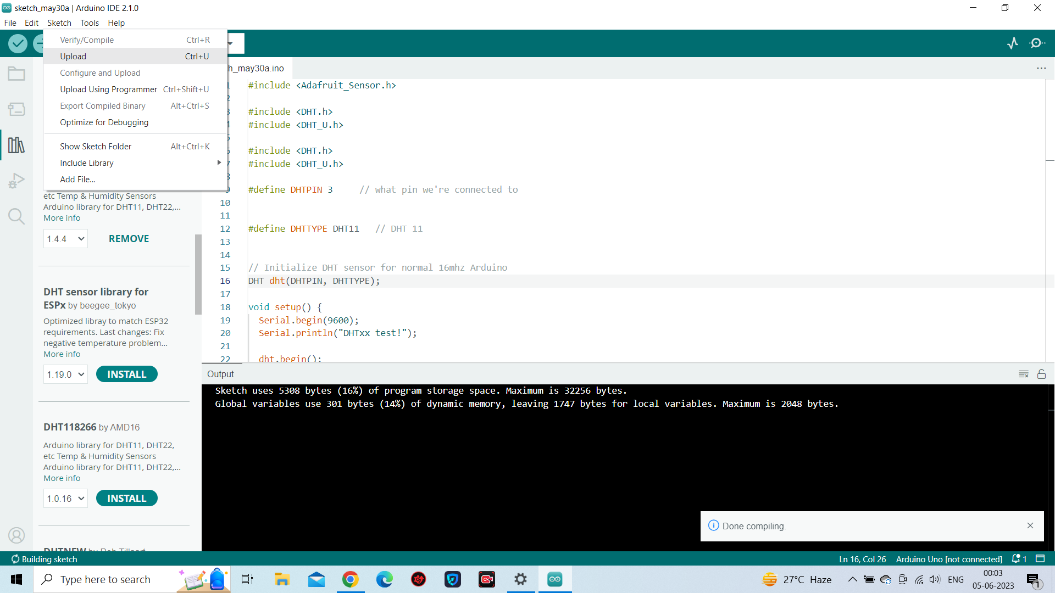

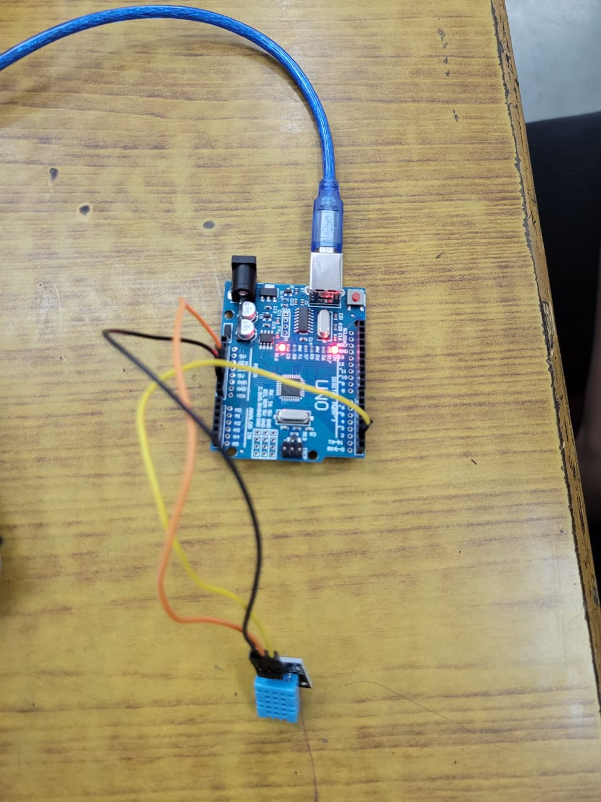

1. Check output on serial monitor.

**RESULT:** The sensor is measuring and collecting temperature and humidity data from surroundings.

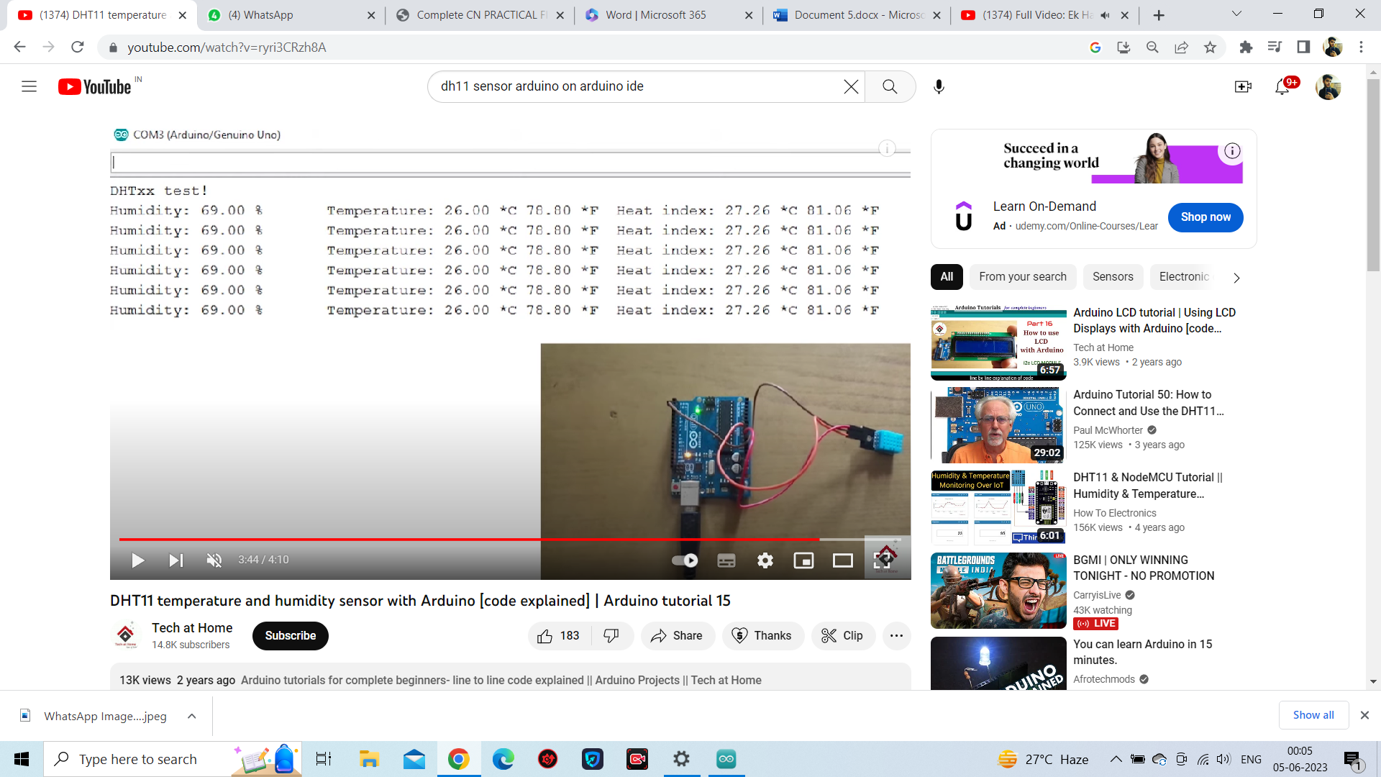

**EXPERIMENT-10**

**AIM :** To interface Ultrasonic sensor (HC-SR04) with ARDUINO and write a program to measure and print distance readings.

**MATERIAL REQUIRED:** Arduino micro-controller, USB Connector, Computer, Smartphone, LED, Ultrasonic sensor(HC-SR04), Male to Female connector wires.

**CODE :**

const int trigPin = 12;

const int echoPin = 11;

long duration;

int distance;

void setup() {

pinMode(trigPin, OUTPUT);

pinMode(echoPin, INPUT);

Serial.begin(9600);

}

void loop() {

digitalWrite(trigPin, LOW);

delayMicroseconds(2);

digitalWrite(trigPin, HIGH);

delayMicroseconds(10);

digitalWrite(trigPin, LOW);

duration= pulseIn(echoPin, HIGH);

Distance=(duration\*0.034)/2;

Serial.print("Distance: ");

Serial.println(distance);

}

**Procedure:**

1. Connect the HC-SR04 sensor to the Arduino Board. The HC-SR04 sensor has 4 legs, with two legs serving as the transmitter and receiver. The third leg should be connected to the power supply, while the fourth leg should be connected to the ground.

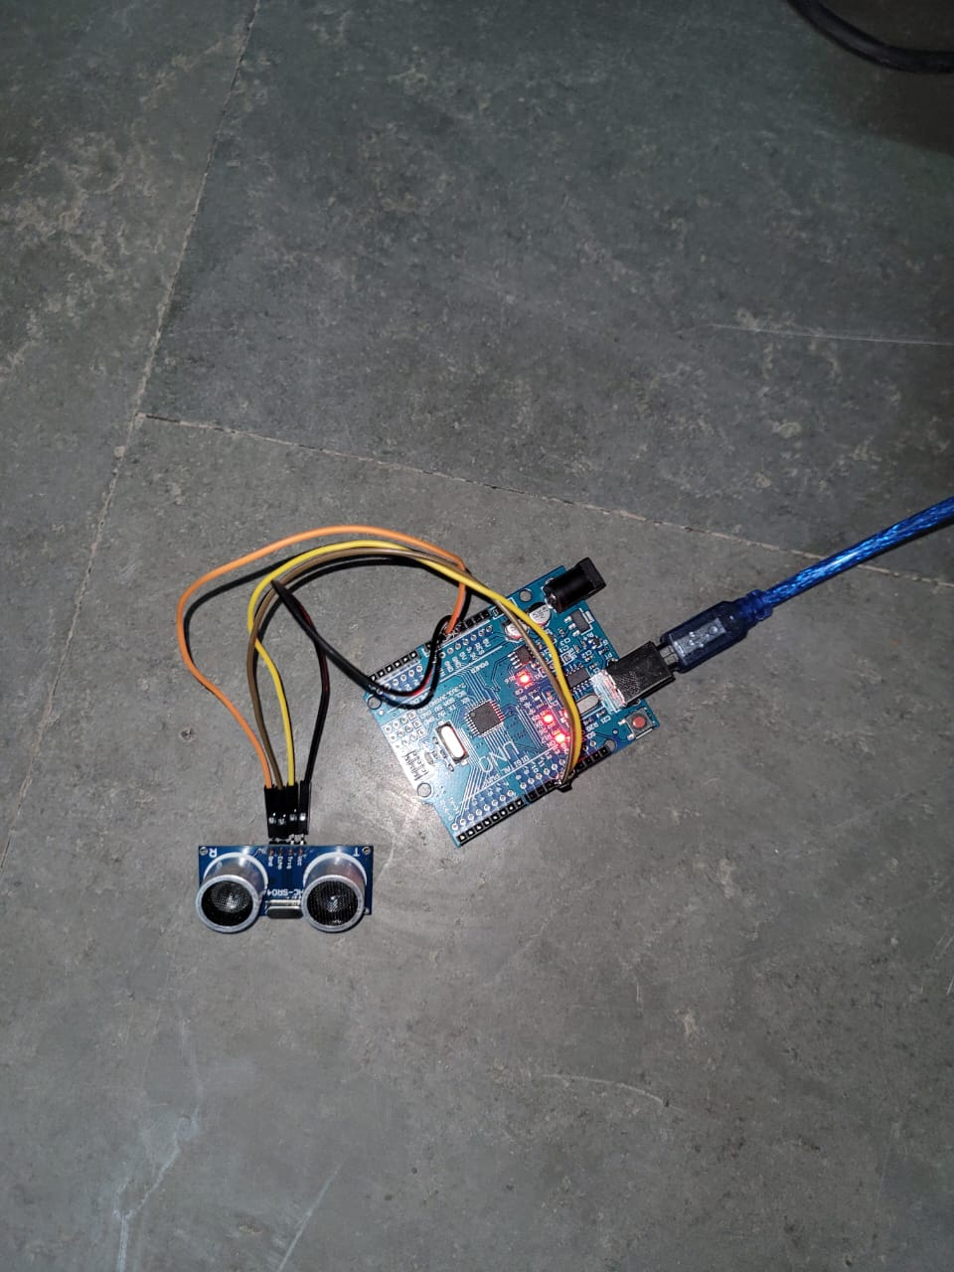

1. Now connect the Arduino Board to your laptop or PC. Select the Arduino Board from the Boards section in Arduino Uno and choose the Port through which it is connected.



1. Then write down the code for the DHT11 sensor to measure temperature and humidity, and store the readings in the float data type.

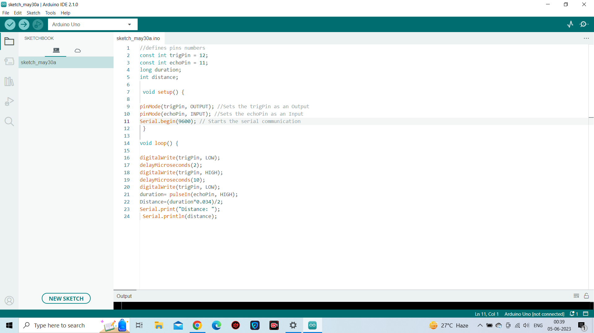

1. Verify , Compile and Upload the program to Arduino.

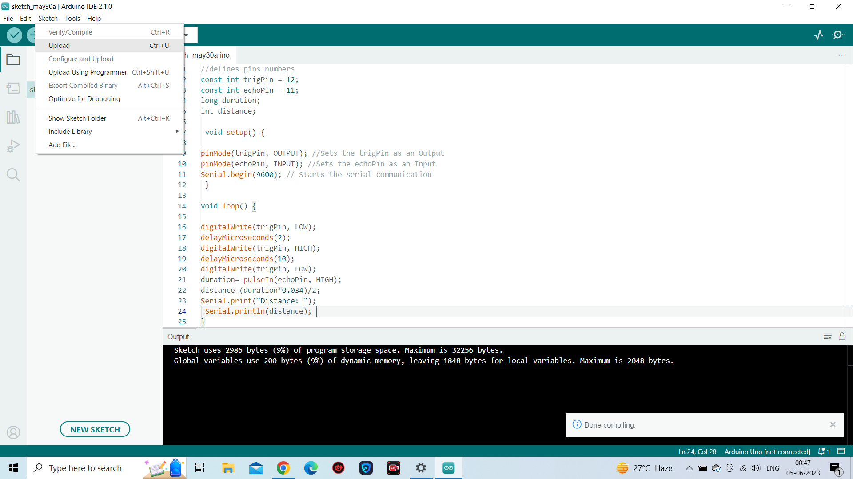

1. Check Serial Monitor for the output.

**RESULT:** The ultrasonic sensor is measuring and collecting distance data from surroundings.



